*To order an annual for your child, please*

*complete and return this note to the class teacher.*

**Level Annual Quantity RRP Total**

S & J Infants Súgradh €

1st & 2nd Class Spraoi €

3rd & 4th Class Siamsa €

5th & 6th Class Sonas €

**TOTAL**

Name:

Class:

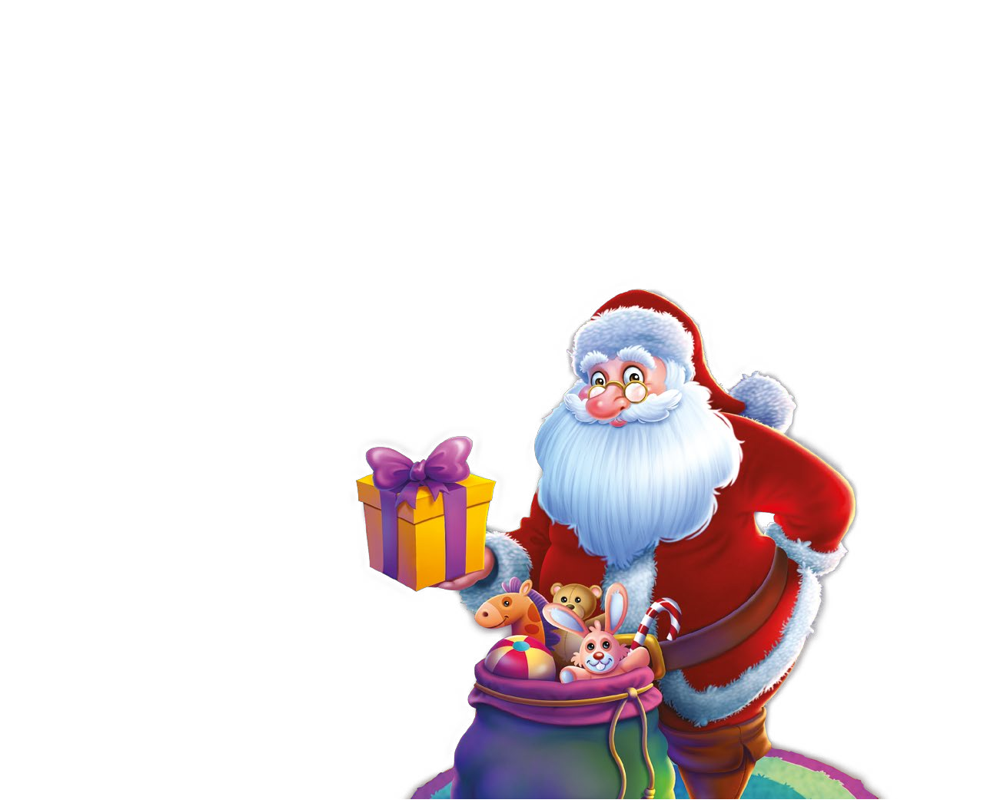

*If you wish*

*please com*

**Class**

Junior & Se

1st & 2

**Bursting with activities,** 3rd &

**jokes, quizzes, interviews**

**and stories!** 5th &

**AMAZING**

**PRIZES** Name: ____

**TO BE WON!** Class: _____