Unit 7: March (Marching into March)

Lesson | Resource | Musical Concepts | Strand | Strand Unit | Content objectives (The child will be able to ...)
1 | Marching Song  (song 1) | Pulse, Structure | Performing | Song Singing | - Sing the song Marching Song  - Use actions to reinforce a two-beat (march) rhythm  - Learn a simple melodic ostinato to sing with the song
2 | When the Saints Go Marching In  (listen, respond) | Pulse | Performing | Literacy | - Sing the song When the Saints Go Marching In  - Identify and clap a simple two-beat (march) rhythm from notation
 |  |  | Composing | Improvising and Creating | - Invent and write simple (march) rhythm patterns
3 | Three Marches  (listen, respond) | Style; Pulse; Dynamics; Timbre; Tempo; Texture | Listening and Responding | Listening and Responding to Music | - Listen to three marches and identify the differences between each one  - Develop an awareness of dynamics and timbre (march being played by instruments or sung)  - Talk about the pieces of music and express preferences
4 | The Ants Go Marching  (song 2) | Pulse | Performing | Song Singing | - Sing the song The Ants Go Marching with a sense of dynamic control  - Perform the song with a sense of pulse, adding suitable actions
 |  |  | Composing | Improvising and Creating | - Create alternative lyrics for the rhyming lines
Curriculum Integration |  | Literacy / Reading / 4. Phonological and phonemic awareness

Lesson 1: Marching Song (Song 1)
A march is a song with a strong marching rhythm. The Marching Song has a very simple two-beat rhythm and is a good introduction to marching rhythms.

Resources
Lesson 1: Marching Video (digital)
Lesson 1: Marching Band flashcards (digital)
Lesson 1: Marching Chant (digital)
Lesson 1: Marching Song (digital)

Steps / Teaching Notes
- Have a discussion with the children about marches and marching:
  - Who might you see marching? (Soldiers, musicians … etc.)
  - When might you see people marching? (Parades, funerals, important occasions …)
  - Do we have to have music when we march? (No. We can chant or say ‘left, right, left, right’.)
  - Why do we say ‘left, right, left right’ when we march? (To stay together.)
- Explain that we can also count ‘1, 2’ when we listen to a march.
- Digital activity – Marching Video/Marching Band Flashcards: Play the video and display the flashcards. Discuss with the children.
- Digital audio file – Marching Chant: Play the chant shown below teach it to children. The children can slap their knees or march around the room (or on the spot) as they say the chant. They should start with their left hand or foot. The chant is repeated ad lib.

Left, right

Left, right, I

Did all my work and I

Got it all right

- Digital activity – Marching Song: Explain to children that they are going to learn a song about marching. Play the song and teach the ostinato line ‘Left, right …’. Note: A rhythmic ostinato is a short, constantly repeated rhythmic pattern.
- Play the track and teach the song/melody, ‘Sing a song, as we go…’.
- When the children are familiar and secure with each part, divide the class in two and assign a part to each group. The two groups perform the two parts together.
- Alternate the groups and sing the song again.
- The group singing the ostinato (‘Left, right …’) might add a rhythmic ostinato by slapping alternate knees as they sing ‘Left, right, left, right …’.
- The children might perform the song as they march around the hall or schoolyard.

Don’t forget - always start with the left hand/foot!

Weblinks
Children may enjoy hearing these well-known marches from the films, Star Wars and Superman:

Imperial March (Darth Vader’s Theme)
https://www.youtube.com/watch?v=IkanoEmIcHM

Superman – Main Theme
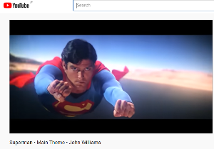
https://www.youtube.com/watch?v=78N2SP6JFaI

Lesson 2: When the Saints Go Marching In (Song 2)
This song originated as a Christian hymn but is often played by jazz bands. The most well-known version was recorded by Louis Armstrong in 1938.

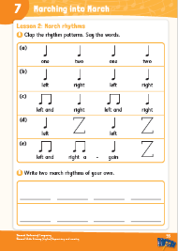
Resources
Lesson 2: When the Saints Go Marching In (digital)
Pupil book, page 55

Steps / Teaching Notes
- Digital Activity - When the Saints Go Marching In: Play the song and ask the children to tap or slap their knees one at a time on the beat (left, right, left right…) as they listen to the song. Note: Begin to tap on the word ‘saints’ on the left knee.
- Play the track and teach the song.
- Pupil book, p. 55 – Activity A: Each of the five rhythm patterns, a-–e, fits into four beats. The children clap the rhythms as they say the words. To reinforce the rests, the children could do an action like placing their hands on their heads for the rest beats in rhythm patterns d) and e).
- Pupil book, p. 55 – Activity B: The children write two march rhythms of their own using ta, ti-ti and rests. The rhythms should fit into four beats as per the rhythms in Activity A.

Weblinks
Children may enjoy watching this video of Louis Armstrong performing When the Saints Go Marching In
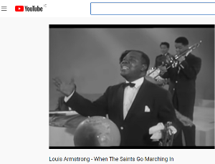
https://www.youtube.com/watch?v=wyLjbMBpGDA

Lesson 3: Three Marches
In this lesson, children listen to three very different types of marches:
- Do You Hear the People Sing? (Les Misérables) – a revolutionary song, calling on people to overcome adversity
- The Liberty Bell March – an American military march by John Philip Sousa
- Máirseáil Righ Lir (King Lir’s March) – an elegant march by Irish composer, Patrick Cassidy

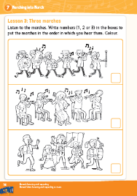
Resources
Lesson 2: Excerpts from Three Marches (digital)
Lesson 2: The Liberty Bell March (digital)
Lesson 2: Máirseáil Righ Lir (digital)
Lesson 2: Do You Hear the People Sing? (digital)
Pupil book: Page 56

Steps / Teaching Notes
- Pupil book, p. 56: Explain to the children that they are going to hear three different marches and that each of the marches can be matched with a picture on this page. Discuss the pictures.
- Digital audio file – Excerpts from Three Marches: Play the track and ask the children to number the marches in pupil book in the order they hear them played. When they have completed this activity, discuss why they numbered them in this order.
- Digital audio file – The Liberty Bell March: Play the track and discuss where they might hear this kind of march? (A parade.) What instruments do they hear? (Lots of brass instruments, cymbals, drums.) Listen out for the tubular bell which sounds in the middle section. How does the march end? (With a crash!)
- Digital audio file – Máirseáil Righ Lir: Play the track. How would you describe this march? (Quieter, gentler, softer.) What instruments do you hear? (Strings, woodwind.) Do you think you might hear this march at a St Patrick’s Day parade? (No.) Can you suggest when this march might be played?
- Digital audio file – Do You Hear the People Sing?: Play the track. What is the difference between this march and the first one you heard? (It’s sung and it is slower.) Do you hear men or women singing? Is it just one voice? (No, a choir of men and women sing the chorus.)
- Ask the children to pick their favourite of the three marches and explain why.

Weblinks
Children may enjoy watching the below videos:

The Liberty Bell performed by the U.S. Marine Band
https://www.youtube.com/watch?v=x7FD9PNpfpo

Do You Hear the People Sing? (Les Misérables)
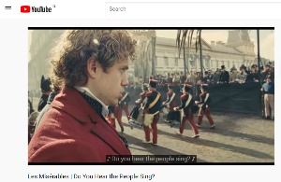
https://www.youtube.com/watch?v=1q82twrdr0U

Lesson 4: The Ants Go Marching (Song 3)
This is a well-known marching song that helps children learn about rhyming words as well as numbers.

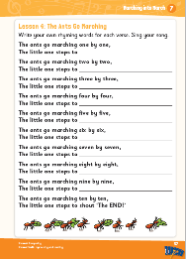
Resources
Lesson 4: The Ants Go Marching (digital)
Pupil book: Page 57

Steps / Teaching Notes
- Digital activity – The Ants Go Marching: Play the track and teach the song.
- Discuss the rhyming pattern of the lyrics. (‘The ants go marching one by one, the little one stops to suck his thumb … two by two … shoe …’) Ask the children for alternatives to those on the track.
- Pupil Book, p. 57: The children create rhyming alternatives for each verse. Note: this is a fun activity and can be done as a class, group, paired or individual activity.

Weblinks
Children may enjoy watching the below video from Super Simple Songs:

https://www.youtube.com/watch?v=2S__fbCGwOM

