Unit 1: This Is Me! (September)

Lesson | Resource | Musical Concepts | Strand | Strand Unit | Content objectives (The child will be able to...)
1 | This is Me  (song 1) | Dynamics;  Pitch;  Pulse;  Style | Performing | Song Singing | - Sing the song This is Me  - Identify the marching beat  - Develop an awareness of how dynamics and texture affect the mood of a piece of music.
2 | Rhythm and Pulse  (literacy) | Pulse;  Duration | Performing | Literacy | - Clap simple four-beat rhythm patterns  - Understand that a crotchet represents one beat and a quaver represents half a beat  - Recognise a 4/4 time signature and its associated pulse
 |  |  | Composing | Improvising and creating | - Compose a four-bar rhythm pattern in 4/4 time
3 | Dvořák’s Symphony No 9 ‘New World’ 2nd movement  (listening) | Tempos;  Dynamics;  Timbre;  Texture;  Pulse;  Style | Listening and  Responding | Listening and Responding to Music | - Listen and respond to Dvořák’s Symphony No 9 ‘New World’ 2nd Movement  - Develop an understanding of musical concepts (elements of music) including tempo, dynamics, timbre, texture and style  - Learn about woodwind instruments
4 | When I Grow Up (from  Matilda)  (song 2) | Tempos;  Dynamics;  Timbre;  Texture;  Pulse;  Style | Performing | Song Singing | - Sing the song When I Grow Up with actions  - Develop a sense of musical style  - Discuss the elements of music in relation to the song
5 | Trasna na dTonnta  (amhrán) |  | Performing | Song Singing | - Sing the traditional Irish song Trasna na dTonnta  - Perform the song with a percussion accompaniment

Lesson 1: This is Me! (Song 1)
The Greatest Showman tells the story of P.T Barnum and his rise to fame as a circus show director. The movie highlights the importance of authenticity and believing in yourself. Keala Settle signs This Is Me in the movie, while performing the role of Lettie Lutz, The Bearded Lady. The song became an international hit, and it reached top positions in charts in several countries, including the UK and Australia. It also obtained a Golden Globe Award for the Best Original Song of 2017. The song is dramatic and provides an opportunity to explore dynamics (loud /soft) with the children.
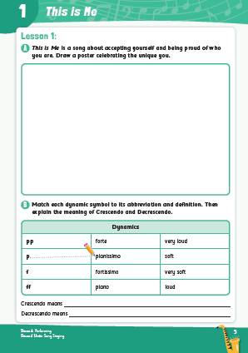
Resources
Lesson 1: This is Me (digital)
Lesson 1: Dynamics Flashcards (digital)
Pupil book: Page 4

Steps / Teaching Notes
- Ask the children if they have seen the musical The Greatest Showman. Explain the background of the song to them.
- Digital activity – The Greatest Showman: Play the song and allow the children to familiarise themselves with the melody and lyrics.
- Point out that this is a marching song and ask the children if they can identify the time signature (4/4 time). Encourage the children to march to the pulse, clapping their hands on every second beat.
- Digital activity – Dynamics Flashcards: Use the flashcards to explain the concept of dynamic to the class. Dynamics are how loud or soft music is sung or played. When music is loud, we refer to it with the Italian term forte; when it is soft, we refer to it as piano. There are also terms for changes in volume: When music gets gradually louder, it is known as a crescendo and when it gets quieter, it is known as a decrescendo.
- Point out that dynamics play a very important role in this piece of music. The shift in volume is used to create a dramatic effect and to highlight certain words. Ask the children if they can identify any parts of the song that are particularly loud or quiet.
- Teach the song verse by verse.
- Dynamics Game: Once the children are confident with the melody and the lyrics, you can plan a dynamics game with them.
  - Ask one child to be the conductor of the class.
  - When they hold their hands high, the class must sing loud (forte) and when they hold their hands low, the children must sing quietly (piano).
  - The conductor can choose to get gradually louder (crescendo) and gradually softer (decrescendo), or suddenly louder (subito forte) or suddenly softer (subito piano).
- Pupil Book, p. 4: Have the children complete the pupil book activities.
- Draw the children’s attention to the harmony that can be heard in the chorus. Once the class is familiar enough with the song, divide them into two groups. Have one group sing the melody and the other group sing the harmony.
Lesson 2: The Crotchet, Quaver and Crotchet Rest
In this lesson, children revise the rhythm patterns ta and ti-ti which they are familiar with from previous classes. They are also introduced to the formal terms crotchet, quaver and crotchet rest. They will recognize the difference between rhythms and beats and create their own rhythm pattern to a 4/4 time signature.

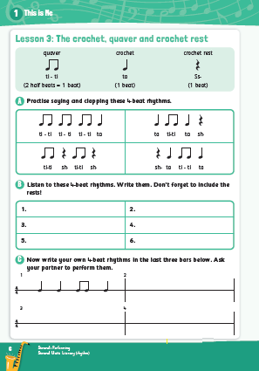
Resources
Lesson 2: Rhythm Flashcards (digital)
Lesson 2: Four-Beat Rhythms (digital)
Lesson 2: Pupil Book, p.5

Steps / Teaching Notes
- Digital Activity – Rhythm Flashcards: Use the flashcards to revise ta (crotchet), ti-ti (quavers) and sh (crotchet rest) with the children. Explain that a single quaver is half a beat but that ti-ti (two quavers) is equivalent to ta (one crotchet ). A crotchet rest is effectively a silence for one beat.
- Pupil Book, p. 5: Clap the first rhythm from the pupil book and invite the children to clap it back following a call and response format. Then, in pairs, invite the children to clap the other four-beat rhythms in Activity A in the pupil book to each other. As an extension, encourage them to clap a different four-beat response to the first rhythm. Alternatively, ask one of the children to clap a rhythm and have the class repeat it.
- Digital Audio File – Four-Beat Rhythms; Pupil Book, p. 5: Play the six four-beat rhythms in turn and have the children write down each rhythm in the pupil book (Activity B).
- Pupil Book, p. 5: Next, invite the children to compose and write their own four-beat rhythms. Ask them if they can identify the time signature. (It is represented as 4/4, because there are 4 beats in each bar.) The first bar is completed for the students. They must compose the following 3 bars. This activity can be completed in pairs or groups.
- After they finish their compositions, have each pair or team clap one bar for the class and have the class clap it back. You can also challenge the students to form a rhythm chain:
  - Each team selects one of their bars.
  - One team starts by clapping theirs, when they are done, the next team starts with their composition, and so on. They shouldn't miss a beat between teams so that you have one long rhythm chain.
  - Help them by signalling to each team when it’s their time to start. You can go very slowly at first and gradually speed up once the class has practiced enough.
  - See if the children can make it one or two rounds without stopping.

Lesson 3: Dvořák: Symphony No. 9 from ‘The New World’ (2nd Movement)
Antonín Leopold Dvořák was a Check composer who lived during the second half of the nineteenth century. His work was internationally acclaimed, and in 1892 he moved to the United States to be the director of the National Conservatory of Music. The next year he was commissioned to write Symphony No 9, which is said to be one of his greatest triumphs. According to the composer’s own notes, the second movement of the symphony (Largo) was inspired by a Native American Chief’s journey across the American plains. Some say that it also portrays Dvořák’s longing to return home.
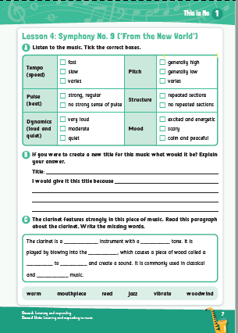
Resources
Lesson 3: An Introduction to Antonín Dvořák (digital)
Lesson 3: Dvořák Symphony No 9 ‘New World’ (2nd movement) (digital)
Lesson 3: Elements of Music Video (digital)
Lesson 3: Elements of Music Flashcards (digital)
Lesson 3: Woodwind Instrument Flashcards (digital)
Lesson 3: Pupil Book: p 6

Steps / Teaching Notes
- Digital activity: An Introduction to Antonín Dvořák: Explain to the children that they are going to listen to a famous piece of classical music written by the composer Antonín Dvořák. Click through the PowerPoint to give some background information about Dvořák.
- Point out to the children how this movement may reflect his homesickness while living in America. Ask them if they have ever been on a long trip or someplace where they missed home.
- Digital audio file: Symphony No 9 ‘New World’ (2nd movement) – Play the listening track for the children.
- Digital activity: Elements of Music Video; Elements of Music Flashcards: Revise the elements of music using the video and flashcards. (Note: the elements of music are also listed at the start of the pupil book for easy reference: dynamics, tempo, texture, pitch, pulse, structure, timbre, style).
- Pupil book, p.6 - Play the track again and have the children complete Activity A in the pupil book. Then discuss the track with the children:
  - Tempo – Is the movement fast or slow? (slow). Does the tempo change throughout the excerpt? (No, it is generally slow throughout
  - Pulse – Can the children clap to the beat of the music? (No – there is no strong pulse or beat)
  - Pitch – is the pitch high, low or a combination of both? (A combination of both)
  - Dynamics – Is the music loud or soft? (Mainly soft)
  - Texture / Timbre – Are there a lot of instruments playing together (thick) or few instruments (thin). (At the start, there are mainly brass instruments, then a woodwind instrument - the cor-anglaise - plays a solo).
  - Style – What is the mood of the music? (Calm and peaceful)
- Digital activity: Woodwind Instrument Flashcards – Play the track again and ask children to pay particular attention to the cor anglaise solo. Explain that the cor anglais is a woodwind instrument with a rich tone this is commonly used to play solos. Dvorak’s ‘New World -Second Movement’ is one of the most famous examples. Like the oboe instrument, it has a double reed which vibrates and creates a sound.

Lesson 4: When I Grow Up (Song 2)
This song is from the musical Matilda, which is based on a book with the same title written by Roald Dahl. It tells the story of a little girl who loves to read and learn. The song identifies all the things a child imagines they are going to do once they ‘grow up’, for example: eat sweets every day on the way to work and go to bed late every night.

Resources
Lesson 1: When I Grow Up (digital)

Steps / Teaching Notes
- Before you play to the song, ask the children what sort of things they would like to do when they are grown-ups that they are not allowed do as children. Create a list on the blackboard or have them write a couple of examples in their notebooks; You will come back to this later.
- Digital activity – When I Grow Up: Listen to the song and then refer to the elements of music (i.e., dynamics, tempo, style, etc). In pairs, ask the children to discuss the elements in relation to the song they just heard.
- Teach the song verse by verse, discussing the lyrics. Would they also like to do the things that the children of the song want to do?
- Have the class perform the song with good use of dynamics and expression. Have the children create their own actions to the song when performing.
- Return to the initial question you presented to the class. Rewrite the song using the examples the class gave for things they would like to do when they grow up. Have the class perform this new version with their own actions.

Weblinks
Children may enjoy watching this video performance of the song on the The Late Late Toy Show:
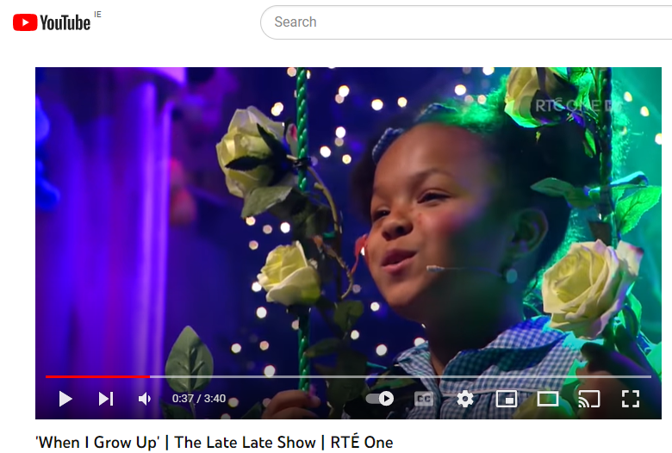

https://www.youtube.com/watch?v=zp7MvUJxqwY

Lesson 6: Trasna na dTonnta (Amhrán)
Trasna na dTonnta is a traditional Irish song that comes from Gweedore in Co. Donegal. This lively song is a narration of a rover who is returning to Ireland following his travels abroad.

Resources
Lesson 1: Trasna na dTonnta (digital)

Steps/ Teaching Notes
- Introduce the students to the song and explain that it is an Irish traditional song about a rover who is returning home to Ireland after exploring abroad. The rover is really looking forward to returning to the country he loves so much.
- Digital activity – Trasna na dTonnta - Play the song, allowing the children to familiarise themselves with the melody of the song. They can hum and follow along with the lyrics.
- Teach the song verse by verse. Point out that Irish traditional song singers do not usually place an emphasis on dynamics.
- Invite the children to clap the pulse (or beat) of the song.
- Introduce untuned percussion instruments such as the tambourine, wood block and shakers.
- Perform the song using the percussion instruments as an accompaniment.

