First Year Summer Exam
Junior Cycle History

Time: 1 Hour

Name

Class

Answer all three questions in the spaces provided.

Question 1 | /33
Question 2 | /33
Question 3 | /34
Total | /100

Question 1: The Renaissance
i) Between 1400 and 1600, many important events took place. In the box below, create a timeline, listing what you think are some of these important events.
_______________________________________________________________________________

ii) Identify two reasons why the Renaissance began in Italy.
First:
Second:

iii) Name a person that you have studied and one way in which they contributed to change in the field of art or science during the Renaissance.
Name:
Change:

iv) Why is the Renaissance considered to be historically significant?

v) Identify one way in which the Renaissance contributed to both the Age of Conquest and Colonisation and the Reformation.

Question 2: The Age of Exploration, Conquest and Colonisation
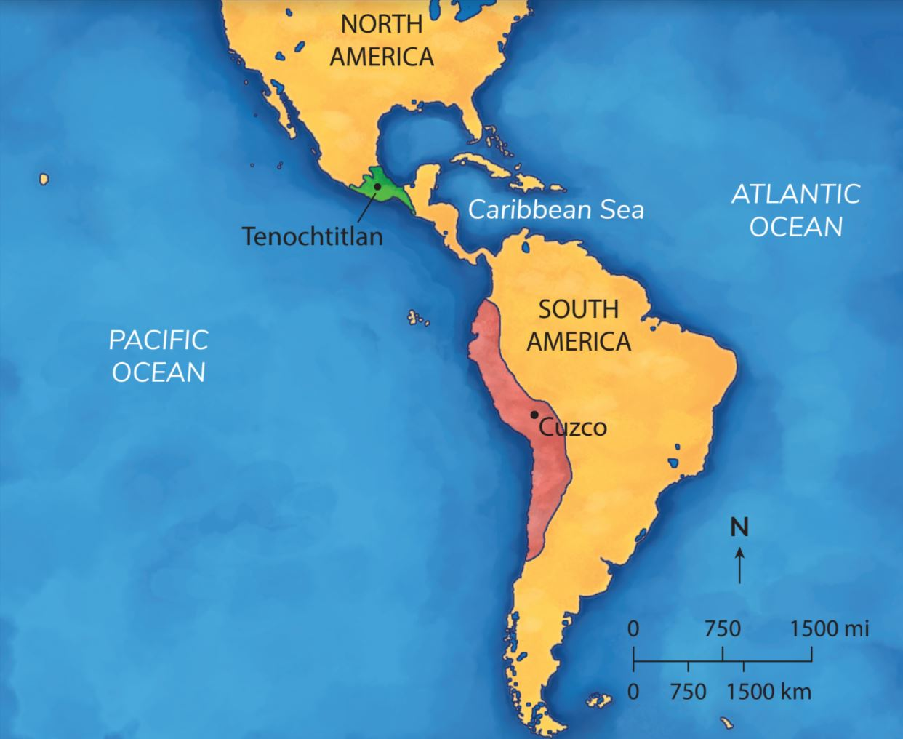
i) Identify the two civilisations marked on the map above.
Civilisation marked in green:
Civilisation marked in red:

ii) Give two reasons why Europeans were looking to find new trade routes in the fifteenth century.

iii) Why is the legacy of this period seen as controversial?

iv) Name a European conquistador you studied who went to South America during the 1500s.

v) Give an account of the conquest undertaken by the conquistador you have chosen, based on the evidence you have studied.

Question 3: The Reformation
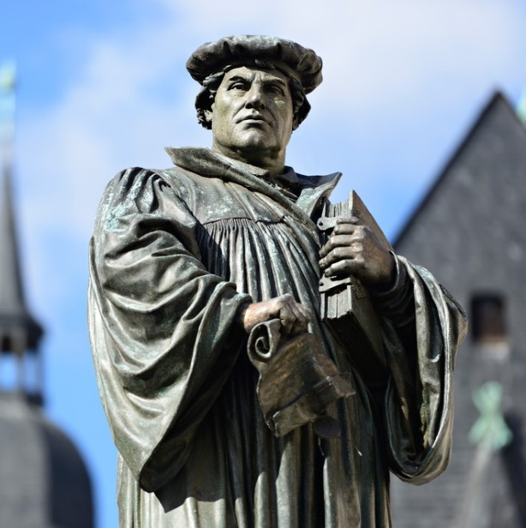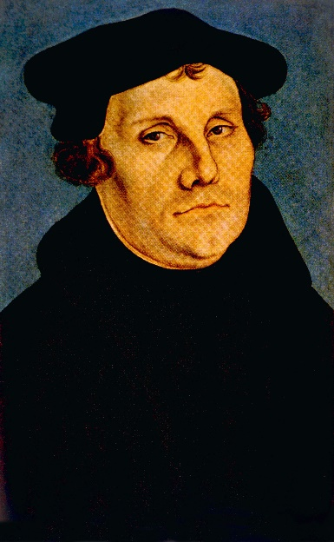
A
B

A: Monument of Martin Luther on the town square of Eisleben, Germany, the town of his birth and death. The monument was created in 1883 by Rudolf Siemering (1835–1905)

B: Portrait of Martin Luther by Lucan Cranach the Elder, 1529
i) Explain the term ‘Reformation’.

ii) Which of the images above is a primary source? Give a reason for your answer.

iii) Why are historical figures like Martin Luther commemorated?

iv) Other than a monument, identify two ways that a historical figure could be commemorated.

v) We study the Reformation because it led to significant change. Discuss two ways in which the Reformation led to change.

