Year 1
End of Term 1
Geography Examination Paper

Time: 1 hour

Name

Class

Answer all questions.
Question | Mark
Question 1 | /15
Question 2 | /15
Question 3 | /15
Question 4 | /15
Total Marks | /60

Question 1

a) The structure of the Earth
Look at the diagram below. Label the following sections of the Earth. [3]
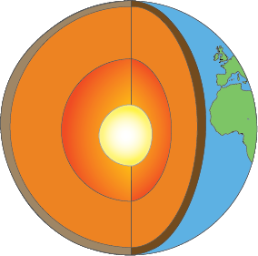
A
B
C

A
B
C

b) Plates of the Earth
Look at the map below. Name the plates labelled X, Y and Z. [3]
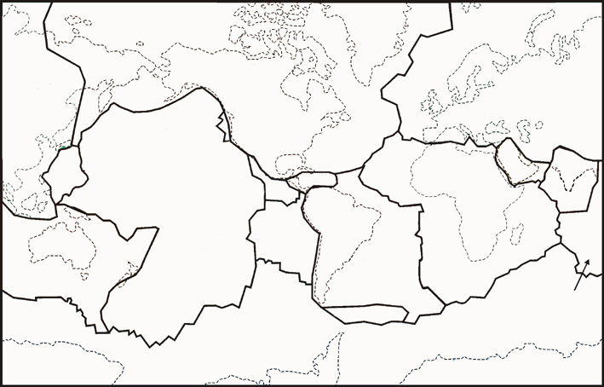
Y
X
Z

X
Y
Z

c) Constructive plate boundaries
Explain how convection currents cause constructive plate boundaries.
Draw a labelled diagram to show a constructive plate boundary. [9]
Diagram

Question 2

a) Volcanoes
Use the space below to draw a diagram of an active volcano.
Show and label each of the following on your diagram:
- Magma chamber
- Cone
- Vent
- Crater
- Ash cloud [5]
Labelled diagram

b) Types of volcano
Complete the table below by writing in the missing words: [4]
Mount St Helens, USA
Erupts regularly
Has not erupted for some time
Mount Etna, Italy

Stage of life cycle | Description | Example
Stage 1: Active
Stage 2: Dormant

c) Distribution of volcanic activity
Look at the diagram and answer the following questions: [3]
Name the plate marked ‘A’.
Identify the country marked ‘B’.
What is the name of the zone marked ‘C’?
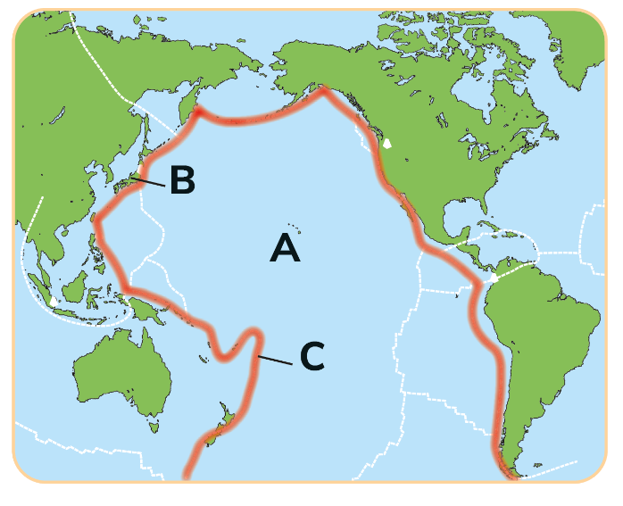

d) Volcanic islands
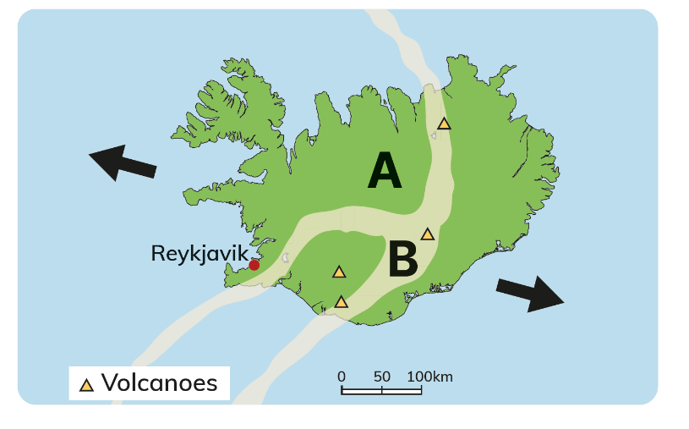
Look at the diagram and answer the questions that follow: [3]
Name the island marked ‘A’.
Identify the feature marked ‘B’.
What do the triangles represent?

Question 3

a) Tectonic landforms
Match the feature in Colum X with the example in Column Y. [3]
Letter | Column X |  | Number | Column Y |  | Letter | Number
A | Fold mountain |  | 1 | Eyjafjallajökull |  | A
B | Severe earthquake |  | 2 | Mount Everest |  | B
C | Volcano in Iceland |  | 3 | Haiti 2010 |  | C

b) Earthquake terms
Look at the diagram below. Write each of the earthquake terms in the correct box. [3]
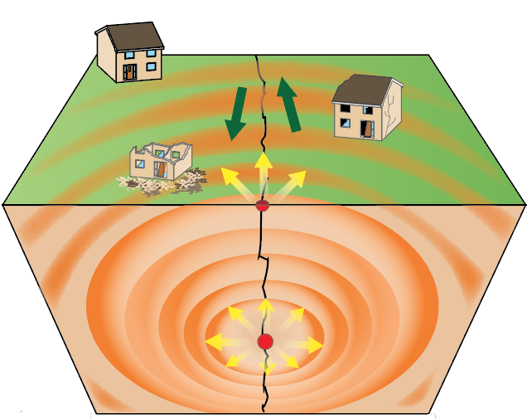
Epicentre • Focus • Seismic waves

c) Natural disasters
(i) Give a definition of a tsunami. [1]

(ii) Explain briefly how a tsunami occurs. [3]

(iii) Describe two ways people responded to a natural disaster that you have studied.
You must give the date and location of the disaster. [5]

Question 4

a) Folding
Look at the diagram below. Identify the features shown by writing the correct letter in the box below. [2]
Feature | Letter
Anticline
Syncline
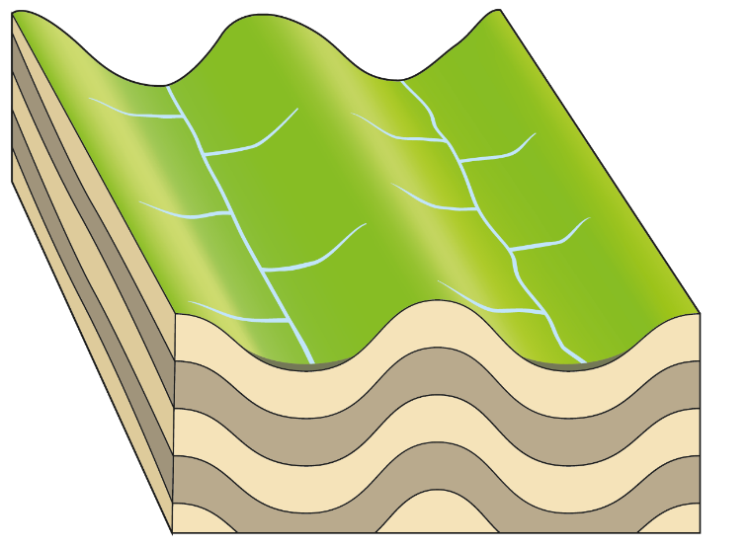
B
A

b) Fold mountains
Explain how fold mountains are formed.
Draw a diagram to support your answer. [9]

Diagram

c) Impacts of fold mountains
Describe one positive and one negative impact of fold mountains. [4]
Positive

Negative

Extra writing space

