Sample Christmas Examination First Year Junior Cycle Business Studies

Time: 1 Hour

Name

Class

Answer all six questions in the spaces provided.

Question 1 | /6
Question 2 | /6
Question 3 | /6
Question 4 | /6
Question 5 | /6
Question 6 | /60
Total | /90

1. Complete the table below by naming the four types of resource you might use to help you through your work, school or home life.
Personal

2. Classify the following sources of income as either examples of regular or irregular:

Overtime; €50 win in a raffle; Jobseekers Benefit; monthly rent; Child Benefit; cash gift; sale of second-hand smartphone; wages and salaries
Regular | Irregular

3. Monika has saved €125 per week for the last year (52 weeks) in her Post Office savings account. Interest is added at 2.5% per year. Calculate how much will be in Monika’s account at the end of the year.
Workings
Answer

4. Explain each of the following terms associated with a household budget.
Budget Surplus
Budget Deficit

5. Identify two advantages of debit cards as a method of payment.
1
2

6. Argo Ltd. is a courier company that operates throughout Ireland. Complete the analysed cash book of Argo Ltd. for the month of March from the transactions provided below and balance the account.

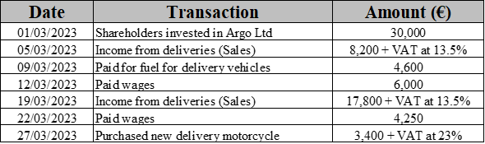
Dr | Analysed Cash Book |  |  |  |  |  |  |  |  | Cr
Date | Details | Total | Shares | Sales | Date | Details | Total | Wages | Fuel | Vehicles

(a) How much did Argo Ltd. have in its bank account at the end of March? _______________________

(b) Outline three benefits to Argo Ltd. of saving its money with a financial institution such as a bank.
1
2
3

(c) Argo Ltd. has encouraged its employees to join the local credit union. Credit union accounts are for people who share a common bond, which refers to the factor that all the members have in common. Suggest three possible factors which might form this common bond and give an example to explain your choice in each case.
1
2
3

(d) Post all the transactions and final analysed cash book balance relating to Argo Ltd. to the relevant ledger accounts below.
Dr | Ordinary Share Capital Account 1 |  |  |  | Cr
Dr | Sales | Account 2 |  |  | Cr
Dr | Fuel | Account 3 |  |  | Cr
Dr | Wages | Account 4 |  |  | Cr
Dr | Vehicles | Account 5 |  |  | Cr
Dr | Bank | Account 6 |  |  | Cr

(e) Prepare a Trial Balance for Argo Ltd on 31 March.
Trial Balance on 31 March
Details | Dr | Cr

