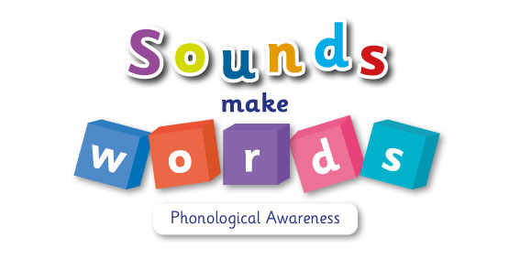

Teacher Notes

SAMPLE PAGES

Contents
Introduction 3
Using the programme 4
Week 1: Listening skills 5
Week 2: Listening skills and auditory discrimination 11
Week 3: Auditory discrimination 18

Introduction

Sounds Make Words: Phonological Awareness is a programme designed to support the teaching and learning of phonological awareness in the Junior Infant classroom. Phonological awareness is the ability to recognise and work with sounds in spoken language. This includes being aware of sounds and words, recognising words that rhyme, counting the number of syllables in a word and recognising words with the same initial sounds, such as ‘bed’ and ‘butter’. Phonological awareness differs from phonics. In phonics, the focus is on the relationships between sounds and letters. Phonological awareness is an aural and oral skill based on the sounds we hear, rather than the letters we see on a page.  The Primary Language Curriculum identifies phonological awareness as an area that requires explicit teaching in our Infant classrooms. Being aware of the structure of spoken language and being able to identify and manipulate sounds is essential to learning to read. Letters represent sounds or phonemes – so, without phonological awareness, phonics makes little sense. Research indicates that phonological awareness is a critical aspect of early reading development (Stanovich, 1994). Research also suggests that systematic and explicit instruction in phonological awareness can successfully jump-start emergent and early readers’ reading performance (McGee and Ukrainetz, 2009).  Some children, for various reasons, do not enter school with the foundational skills they need to develop their literacy skills (such as auditory discrimination and memory, understanding of rhythm and rhyme, and syllabic awareness). These children may begin to learn sounds and letters but they are unlikely to make good progress in reading and writing because they lack the crucial foundation of phonological awareness. These are the children who appear to ‘hit a brick wall’ when it comes to developing reading skills. Therefore, they are likely to need a systematic, structured approach to the development of phonological awareness, where difficulties can be identified effectively and progress can be measured. The purpose of Sounds Make Words: Phonological Awareness is to aid Junior Infant teachers by providing a resource that will help develop these skills in young children. The structured activities and materials in the programme can be used to teach early phonological awareness skills, paving the way for quicker and more effective teaching of phonics. | 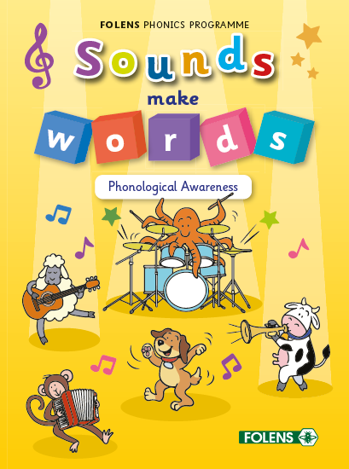  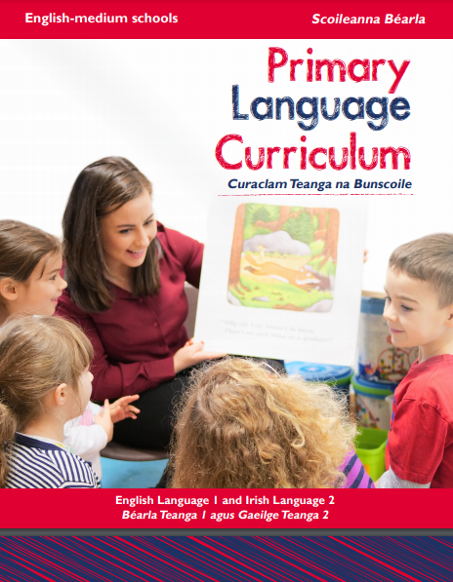

Using the programme

Sounds Make Words: Phonological Awareness is a 13-week programme, with an additional week for assessment. It is envisaged that teachers use this resource from September to December in the Junior Infant classroom, either prior to teaching phonics or alongside their existing phonics programme. Sounds Make Words: Phonological Awareness focuses on several aspects of phonological awareness: listening skills, auditory discrimination, auditory and visual memory, rhyme, syllables, alliteration and blending of syllables.  For each week, the programme consists of the following:  - Four classroom activities that can be carried out at whole-class level or in smaller groups, depending on how each teacher has their class set up.  - Two digital activities that can be completed after classroom activities or at another time. All these activities can be accessed online.  - Two pupil book activities for further practice and consolidation. After each activity, self-assessment can be used to monitor the child’s understanding of the skill taught.  At the end of the programme, a simple assessment can be completed with each child to enable teachers to see what areas may need further attention. This information can then be used to inform literacy teaching in the second term. | 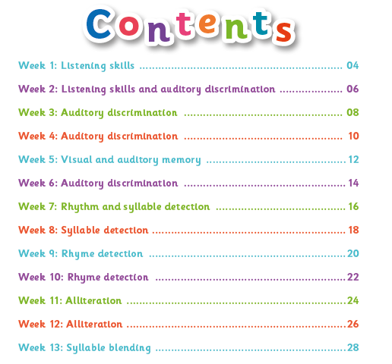  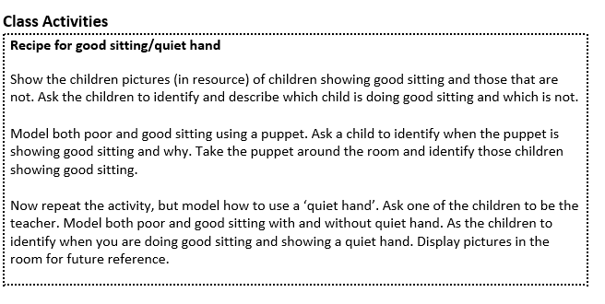  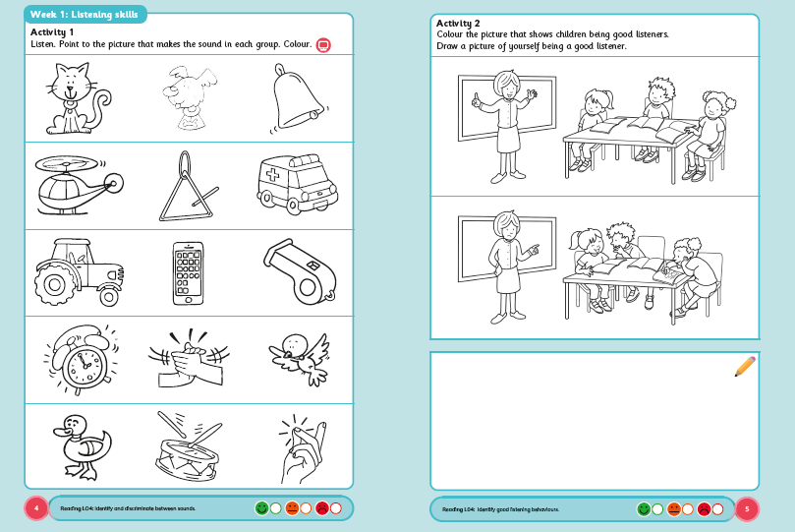

Week 1: Listening skills
Listening skills are crucial to enable all children to fully access all areas of the curriculum. Children tend to enter the Junior Infant classroom without these skills. It is essential that children are explicitly taught how to be good listeners, and that this skill is reinforced throughout the programme. Focus the children’s attention before giving instructions. Use short, simple sentences.

Learning Outcomes | Oral Language | LO1  LO2/3 | Demonstrate attention and active listening  Take part in turn-taking games and respond to his/her name
 | Reading | LO4 | Identify and discriminate between sounds
Resources | - Resource A: Poor Listening/Good Listening  - Puppet  - Resource B: Trip to the Park

Class activities
Recipe for Good Sitting/Quiet Hand

Show the children two pictures (see Resource A: Poor Listening/Good Listening). The first picture shows a child who is not sitting properly and the second picture shows a child who is. Ask the children to identify and describe which child is doing good sitting and which child is not.

Use a puppet to model poor sitting and good sitting. Ask a child to identify when the puppet is showing good sitting and why. Take the puppet around the room and identify those children showing good sitting.

Now repeat the activity, but model how to use a ‘quiet hand’. Ask one of the children to be the teacher. Model poor sitting and good sitting with and without quiet hand. Ask the children to identify when you are doing good sitting and showing a quiet hand. Display pictures in the room for future reference.

Recipe for Good Listening and Looking

Role play poor listening and good listening. Ask a child to tell you something, e.g. what they did last night. Remind the child that, when they are talking, you might listen really carefully or you might not. Then, when they are talking, wriggle and move a lot and don’t listen.

Ask the children: ‘Was I listening? How do you know? What do I need to do to listen carefully?’ Repeat the activity. This time, remain still, but don’t look at the child who is speaking. Look at your watch, out the window, etc.

Ask the children again whether you were showing good listening. Ask the children to show and articulate what it looks like when we practise good listening and looking.

Copy the Teacher

Demonstrate the following activities. Encourage the children as a group to model the actions. Say: ‘We are going to play a game. Listen and watch me carefully so you can play the game too. I am going to make some sounds and I want you to make the same sounds that I make.’

Remember to preface each new activity with: ‘Listen’. The intention is to encourage children to listen to and reproduce sounds.

Carry out some or all of the actions below.

Clap hands Click fingers
Tap finger on table Cough
Stamp one foot Click tongue
Whisper Sing
Whistle Slap knees

Listen for Your Name

Explain to the children that this game helps us to listen carefully to stories.

Tell the children a simple story using all of their names. It could be a story about the children going to the park, on a school trip, taking part in sports day, etc. (See an example in Resource B: Trip to the Park.) Encourage children to listen out for their names and to complete an action every time they hear their name. The following is one example: ‘Jack, when you hear your name, clap your hands once. Jade, when you hear your name, fold your arms. Lucy, when you hear your name, put your hand up.’

Variations: To make it easier, look at each child when they are required to do their action. To make it more challenging, ask children to listen and do an accompanying action for something other than their name, such as a colour, place, animal or number.

Digital activities
Week 1: Activity 1
Sorting Good Listening from Poor Listening

This activity shows photographs of children in the classroom either paying attention or not paying attention. Children sort these pictures into two categories – ‘good listening’ and ‘poor listening’. For each picture, briefly discuss with the children why they are sorting this picture to the particular category. What did they notice about the picture?

Week 1: Activity 2
Following Instructions

In this activity, children respond to nine audio instructions. Click to play the instructions one by one and ask children to follow them. Alternatively, you can read the instructions aloud (see below).

- Clap your hands.
- Touch your toes.
- Fold your arms.
- Put your hands on your head.
- Touch your nose and then touch your ears.
- Stamp your feet and turn around.
- Jump three times.
- Clap your hands, then fold your arms.

You can add on more complex activities for consolidation.

Pupil book activities
Page 4
The purpose of this activity is to ensure that the children can distinguish between sounds and can demonstrate good listening skills.

Launch the digital audio file. Explain to the children that they will listen to each sound and then point to the corresponding image in their book. They can colour in each image as they identify it. Or, at the end, they can colour all the images they identified.
Page 5
The purpose of this activity is to see if the children can identify good listening behaviours.

Children colour the picture that shows good listening. Before asking children to complete the activity, discuss what is happening in each picture. Reinforce what good listening looks like. Finally, ask the children to use the box at the bottom of the page to draw a picture of themselves demonstrating good listening.

Resource A: Poor Listening/Good Listening

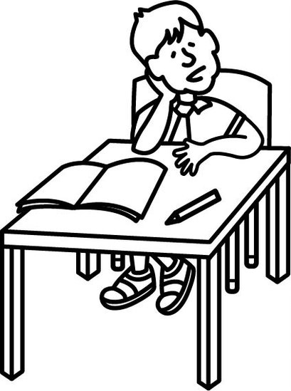

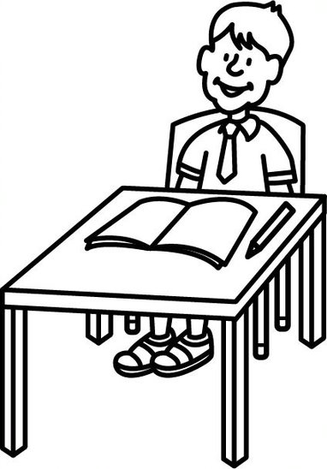

Resource B: Trip to the Park
_______, _______ and _______ went to the park on Saturday. _______ was very excited as he loved playing on the swings. He could go up very high but not as high as _______.

_______’s favourite place in the park was in the playhouse. When he was there, he could watch _______and _______playing.

_______loved playing on the slide. At first, she was afraid to climb the steps, but her friend _______ helped her to be brave.

On the way to the park, the children met _______and _______. _______was very happy to see _______and they ran off to play on the roundabout. _______had a soccer ball in his hand, so _______and _______ran off to play with him. They were all happy to see _______and _______. But _______was upset, as she had lost her hat. ‘Don’t worry,’ said _______, we will all help you find it.’

_______and _______went to look in the trees. _______and _______went to look in the long grass. _______and _______went to check on the path. Suddenly _______heard _______shouting. All the children looked around. _______was pointing to the top of the climbing frame. ‘Look!’ said _______. ‘There’s my hat!’ _______ was very relieved. The children had a great day playing together in the park.

Week 2: Listening skills and auditory discrimination
Auditory discrimination is the ability to recognise, compare and distinguish between distinct and separate sounds. It is important that children develop this skill before they progress to learning letter sounds and words, as the children need to distinguish, categorise and hear sounds that are the same and/or different.

Learning Outcomes | Oral Language | LO1  LO2/3 | Demonstrate attention and active listening  Take part in turn-taking games and respond to stimuli
 | Reading | LO4 | Distinguish and identify familiar sounds  Discriminate between sounds heard and match to a corresponding object
Resources | Resource: Sound Bingo

Class activities
Sound Walk

This is a listening activity that can take place indoors or outdoors. Remind the children about the things that good listeners do: they keep quiet, they pay attention, etc. Encourage the children to show you how good they are at listening. Remind the children why listening carefully is important.

Encourage the children to listen attentively to the sounds around them. Talk about the different sounds they can hear. The children could use ‘cupped ears’ or make big ears on headbands to wear as they go on the listening walk.

After the children have enjoyed a listening walk either indoors or outdoors, make a list of all the sounds they can remember. You could make the list on the whiteboard, or have the children create their own lists by drawing pictures. You may want to record some of the sounds you hear, so that you can play them back. The children could create a collage of the sounds they have heard.
Listen to the Sounds

Remind the children once again of the things that good listeners do. Say: ‘I am going to make some sounds. Listen carefully to see how many sounds you can remember. When I say “Go!”, close your eyes and listen carefully. When I say “Stop!”, open your eyes again.’

Make several noises in a row, e.g. knock on the table, scrape a chair on the floor, drop a book or open and close the door.

Ask the children to name or describe the different sounds they heard. Repeat the activity, adding in more sounds this time. Ask the children which sounds they liked, which sounds they didn’t like, and why.

Listen for the Sound/Identify the Location

Sit the children in a circle. Choose one child to sit in the middle of the circle with their eyes closed. The other children pass around a noisy object, such as a tambourine, while trying to be as quiet as possible. The child in the centre listens carefully for the noise and, if they hear it, points to the location of the sound. Then choose someone else to sit in the centre and the game begins again.

Praise the children for good listening and sitting. To increase the difficulty of the game, a child can be chosen to whisper a name or a noise. Again, the child in the centre listens carefully for the noise and points to the child who is whispering.
Sound Bingo

Give each child a bingo card (see Resource: Sound Bingo).
Play the sounds from the digital file. The children mark off or place a counter over the picture that matches the sound they hear. Depending on the time available, the children can play for three across, three down or the full card.

Digital activities
Week 2: Activity 1
Sorting Environmental and Speech Sounds

In this activity, the children hear eight sounds. Four of these sounds are outdoor sounds and four are speech sounds. The children are asked to sort the sounds into two categories: ‘outdoor sounds’ (racing car, ambulance, wind, birds singing) and ‘speech sounds’ (singing, laughing, talking and crying).

Week 2: Activity 2
Identifying Sounds

The children see eight pictures: ambulance, elephant, dog, cat, bell, drum, clapping hands and duck. Play each sound and ask the children to point to the image that matches the sound they just heard.

Pupil book activities
Page 6
In the pupil book, the children are presented with six pictures. The accompanying digital audio file contains four sounds. The children listen carefully to the sounds they hear and colour the appropriate pictures. The sounds played are: cow, drum, laughing, bell ringing.
Page 7
In the pupil book, the children see three pictures: someone sneezing, a running tap, an aeroplane. The accompanying digital audio file contains two sounds. The children listen carefully to the sounds. They use red to colour the sounds they hear. They use blue to colour the sound they do not hear. The sounds played are: someone sneezing, an aeroplane.

Resource: Sound Bingo

Board 1

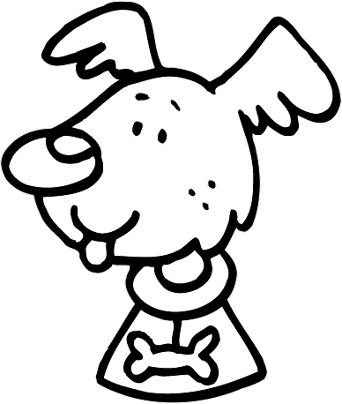 | 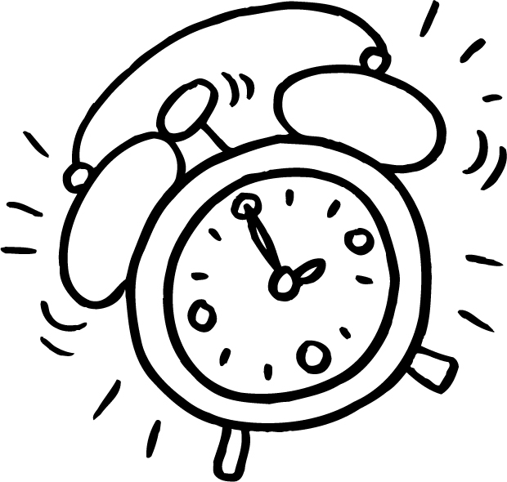 | 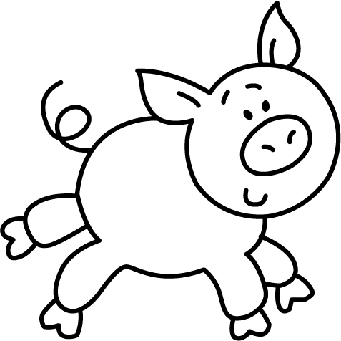
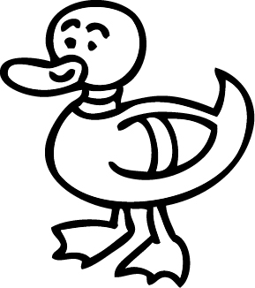 | 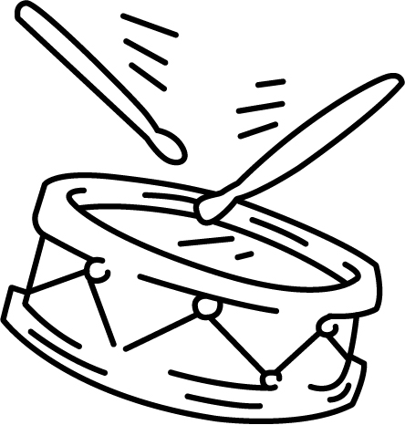
 |  | 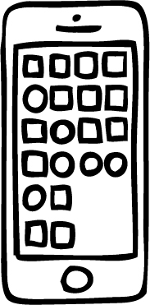

Board 2

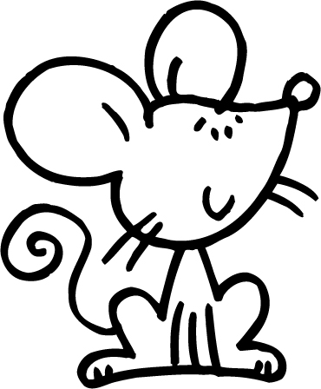

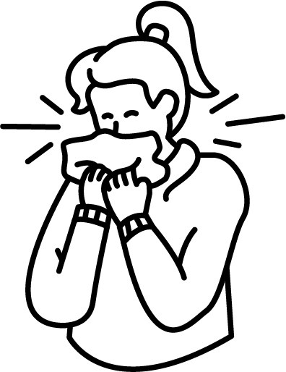

Board 3

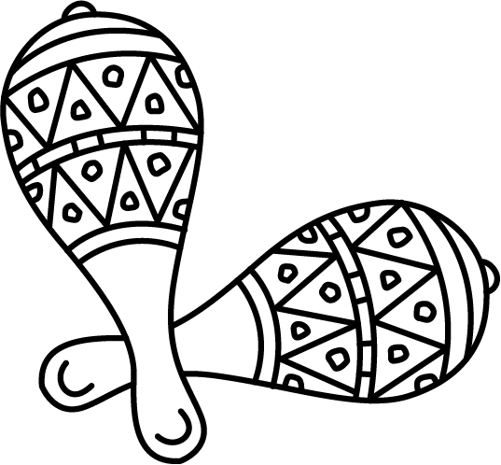

Board 4

Week 3: Auditory discrimination
Activities in Week 3 continue to focus on auditory discrimination. However, this week, the children distinguish between loud sounds and soft sounds, as well as sounds made by objects/instruments and sounds made by speech/vocalising.

Learning Outcomes | Oral Language | LO1  LO2/3 | Demonstrate attention and active listening  Take part in turn-taking games and respond to his/her name  Follow simple directions
 | Reading | LO4 | Distinguish and identify familiar sounds  Distinguish between loud and soft sounds and describe sounds appropriately  Understand the concept of same and different
Resources | - Selection of instruments and noise-making objects  - Teddy bear  - Materials for making shakers – plastic bottles, stones, rice, dried beans, sand, etc.  - Two identical sets of musical instruments of any type

Class activities
Making Sounds

Divide the children into groups and give them a selection of instruments and items that make sounds. Say: ‘We are going to explore making sounds using the instruments on your table. I want to see how many different sounds you can make.’

Give the children two minutes to explore making different sounds. When the time is up, ask each child to model their favourite sound. Model how to describe sounds using terms such as loud/soft/quiet/fast/slow, etc. Encourage the children to describe the sounds in this way.
Where is Teddy?

Arrange the children in a circle. Take one child aside to be the ‘rescuer’. Meanwhile, another child hides a teddy bear somewhere in the room. Ensure that all the other children see where the teddy bear has been hidden.

Tell the children that they are going to help the rescuer find the teddy by singing louder when the rescuer gets closer to the teddy, and quieter when the rescuer is far away from the teddy. Use a familiar song or nursery rhyme that has been previously taught. After the teddy has been found, discuss with the children how they helped the rescuer find the teddy.

Repeat the activity, giving as many children as possible a turn to be the rescuer.

Which Instrument?

For this activity, you will need two identical sets instruments. For example, each set could contain one violin, one drum and one flute.

Explain to the children that some objects can be identified through their sound. Give the children the opportunity to play with the first set, so that they can become familiar with the sound of each of the different instruments. Name the instruments for the children.

Then have one child hide behind a screen or curtain as they choose one instrument from the second set. Ask the child to play the instrument. The other children identify which instrument has been played, either by naming it or by playing the matching instrument from the first set.

You can further develop the activity by have children play a simple rhythm.

Making Shakers
Using plastic bottles or cups, have the children make pairs of shakers containing objects that make the same sound. Contents for the shakers could include sand, rice, pasta, dried beans, stones, etc. Mix up the shakers and ask the children to locate the pairs by shaking them and identifying the ones that make the same sound.

Digital activities
Week 3: Activity 1
Sorting Instrument Sounds from Speech Sounds

In this activity, children hear eight sounds. Four of these are instrument sounds (piano, acoustic guitar, violin, flute) and four are people sounds (talking, humming, crying, singing). The children sort the sounds into the correct category.
Week 3: Activity 2
Sorting Loud Sounds from Soft Sounds

In this activity, children hear eight sounds. Four of these are loud sounds (racing car, ambulance siren, drill, alarm clock) and four are soft sounds (whispering, cat purring, clock ticking, soft rain falling). The children sort the sounds into the correct category.

Pupil book activities
Page 8
In this activity, children discriminate between animal, instrumental and outside sounds. In the pupil book, the children are presented with nine pictures. The accompanying digital audio file contains nine sounds. The children listen carefully to the sounds. They use red to colour the animal sounds they hear. They use blue for the instrument sounds. They use green for the outside sounds.

Page 9
In this activity, children discriminate between loud and soft sounds. In the pupil book, the children are presented with six pictures. The accompanying digital audio file contains six sounds – some loud and some quiet. The children listen carefully to the sounds. They use red to colour the loud sounds. They use blue for the soft sounds.

