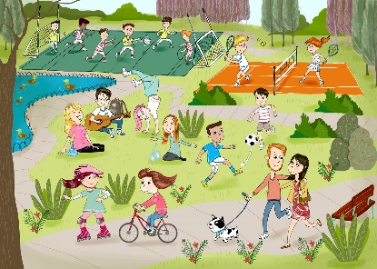
Class | 1st | Theme | Myself
Unit | 1 | Subtheme | Hobbies
Unit genre | Recount
Vocabulary | Tier 1 examples: park, pond, tennis court, tennis racket,  football pitch, soccer, bicycle, cycling, skating/roller blading,  guitar, music, gymnastics  Tier 2 examples: hobby, couple, strolling, chatting
Lesson resources | Hobby picture cards; sentence expanding flashcards

Fortnightly plan
Lesson 1 | Digital poster (Story mode)  Digital poster (Explore mode): Talk and discussion  Categorisation: Whole-class activity  Data chart | Lesson 3 | Digital poster (Explore mode): Talk and discussion  Digital poster (Activity mode): Guess the activity  Pair interview task
Lesson 2 | Digital poster (Story mode): Recap  Digital poster (Question mode)  Don’t say yes or no! | Lesson 4 | Digital poster (Label mode)  Digital poster (Poem mode): Seasons  Acrostic poem

Lesson 1
Digital poster (Story mode)
Play either the Story mode 1 (starters) or Story mode 2 (flyers) for the class, depending on the ability level.

Digital poster (Explore mode): Talk and discussion
Go to the Explore mode of the poster. Ask the children the following questions, using the pen, zoom and spotlight tools to help you:
- Where is everyone in this picture? (The park)
- Why do you think they are in the park?
- Look at the girl doing handstands. What kind of activity is this? (Gymnastics)
- Why do you think the couple is taking their dog for a walk? (Because dogs need exercise)
- What do you call the area where you play football?
- What do you call the area where you play tennis?
- Look at the children on the football pitch. Why are some children wearing red and white outfits and some yellow, blue and white?
- What is around the pond and why is it there?
- Can you name the different types of clothes the people in the poster are wearing?
- What is the difference between a football and a tennis ball? (Bigger/harder/softer than)
- How many team activities can you see?
- How many solo activities can you see?

Categorisation: Whole-class activity
Discuss with the class the different activities seen in the poster. Draw a chart on the board/whiteboard with the headings ‘Indoor’, ‘Outdoor’, ‘Solo’ and ‘Team’.
Have the children decide where each activity should be placed. Be aware that some may come under several headings. See table below for examples:

Indoor | Outdoor | Solo | Team
 | Tennis |  | Tennis
Playing music | Playing music | Playing music | Playing music
Football | Football |  | Football
Skating | Skating | Skating
 | Cycling | Cycling
Chatting | Chatting |  | Chatting
Singing | Singing | Singing | Singing

Ask the children a series of questions on the information gathered, e.g:
- Which activities can only be done outside? (Cycling, tennis)
- Which activities cannot be done on your own? (Chatting, tennis, football)
- Why did we put singing under all four headings?
- Where might you see people playing music outside?
- How can you play music as a team?
- What is the difference between indoor football and outdoor football?
Have children create sentences to describe one of the activities using the information gathered, e.g:
Football – Football is a team sport that can be played indoors or outdoors.
Chatting – People can chat indoors or outdoors with other people
Singing – We can sing as part of a team or solo.

Data chart
Make a real-life data chart with children. Discuss with the children the different hobbies shown on the interactive poster. Lay some hoops on the ground and label each hoop with one of the hobbies highlighted in the poster – football, tennis, music, skating, walking and cycling. Tell the children to stand in the hoop which indicates which one of these is their favourite. Discuss which pastime has the most/least people, order from largest to smallest or smallest to largest, etc. Model language for the children, e.g. Most children in this class like to play football. Some children like to play tennis. Few children like to skate. More children like to play football than cycle. Less children like to walk than skate. Ask the children questions, e.g. Which is the most popular hobby? Which is the least popular hobby? Which hobbies are less popular than…? Which hobbies are more popular than…? Order the hobbies from the most poplar to least popular and least popular to most popular. How many more children like … than …? etc.
Display the results on a graph.

Lesson 2
Digital poster (Story mode): Recap
Play either the Story mode 1 (starters) or Story mode 2 (flyers) for the children again. Make sure they understand all of the vocabulary.

Digital poster (Question mode)
Go to the Question mode of the poster. Listen to each question and discuss the answers with the children briefly.

Q1. | What kind of day is it?
Q2. | What sports are being played in the park?
Q3. | What animals can you see in the park?
Q4. | How can you tell that the group of friends by the duck pond are enjoying themselves?
Q5. | How is the girl on the roller skates preventing herself from being injured if she falls?
Q6. | Do you think the girl on the bicycle should be wearing a helmet? Why?
Q7. | Why do you think the park is especially busy on a sunny day?
Q8. | Can you think of other outdoor activities people might do at the park?
Q9. | Do you think it's a good idea for people to keep their dogs on a leash in the park? Why?
Q10. | Which of the activities on this poster would you most enjoy doing?

Don’t say yes or no!
Place picture cards of the different hobbies (see Lesson resources 1) in an envelope or bag. Invite a child from the class to come up and select a card, keeping it hidden from the rest of the class. Now ask the class to guess what hobby the child has selected by asking questions. The child has to answer all the questions using full sentences and without saying ‘yes’ or ‘no’, e.g:
Class: Is it an outdoor game?
Child: This hobby can be played outside.

Lesson 3
Digital poster (Explore mode): Talk and discussion
Go to the Explore mode with children again. Focus on expanding sentences.
Place the flashcards in Lesson resource 2 in two piles – the who, with, when, where pile and the colour, size, shape, texture and number pile. Model for the children how you can expand on a simple sentence to make it more interesting. Say one simple sentence to the children, e.g. ‘The boy is playing football.’ Pick up a card from the who, with, when, where pile and one card from the colour, size, shape, texture and number cards. Say to the children ‘I have picked up the where card and the colour card. I need to include these in my new sentence. Where is the boy playing football?’ Encourage responses from the children, then ask, ‘What colour is the ball?’ I can say ‘The boy is playing football in the park with the black-and-white ball.’
You can play the game with individual children taking turns to expand on a simple sentence you have chosen, or in small groups with individual sets of flashcards once children are familiar with the game.

Digital poster (Activity mode): Guess the activity
Go to activity mode of the poster. A series of pictures will appear. Ask children to guess the activity to accompany each picture. The pictures shown are: headphones, guitar plec, 3D glasses, shuttlecock, violin bow, arts & crafts, bowling pins, book, marker cones, golf tees, whistle and gardening tools.

Pair interview task
Organise children in pairs and have them interview each other on their favourite hobby. Encourage children to ask ‘wh’ questions like:
- What is your favourite hobby?
- Where do you do it?
- When do you do it?
- Who do you do it with?
- Why do you enjoy it?
To support children you may write the words what, when, where, who, with, and why on the board as an aid. After the interviews, children swap roles and repeat. You can then invite the children to tell the whole class what they have found out about their partner’s hobby.

Lesson 4
Digital poster (Label mode)
Go to the Label mode of the poster. Review the vocabulary. Have children take turns dragging the labels onto the correct location in the poster.

Digital poster (Poem mode): Seasons
Go to the Poem mode of the poster and play the poem, Seasons.

Seasons
By Kerri Ward

In springtime when
it’s nice outside
I take my bike
out for a ride.

In summertime
When the weather’s fine
I like to hike
With a friend of mine.

In autumntime
It makes me smile
To fly my kite
For a little while.

But in wintertime
When the sun won’t shine
It’s nicer to hide
By the fire inside.

Acrostic poem
Divide children into groups. Give each group a different hobby, e.g. football, tennis, skating, gymnastics, singing, etc. As a group, have the children make and perform an acrostic poem about their given hobby, e.g:
Running
Under the posts
Going for the try
Ball touching down
Yes, we won!
Lesson resource 1

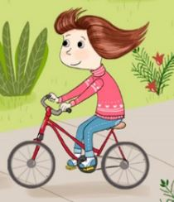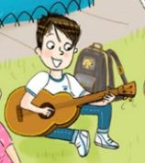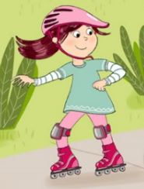

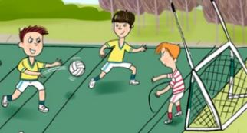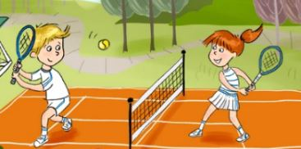

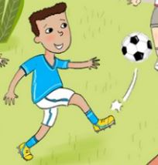

Lesson resource 2
size

shape

colour

texture

number

when

where

with

who

