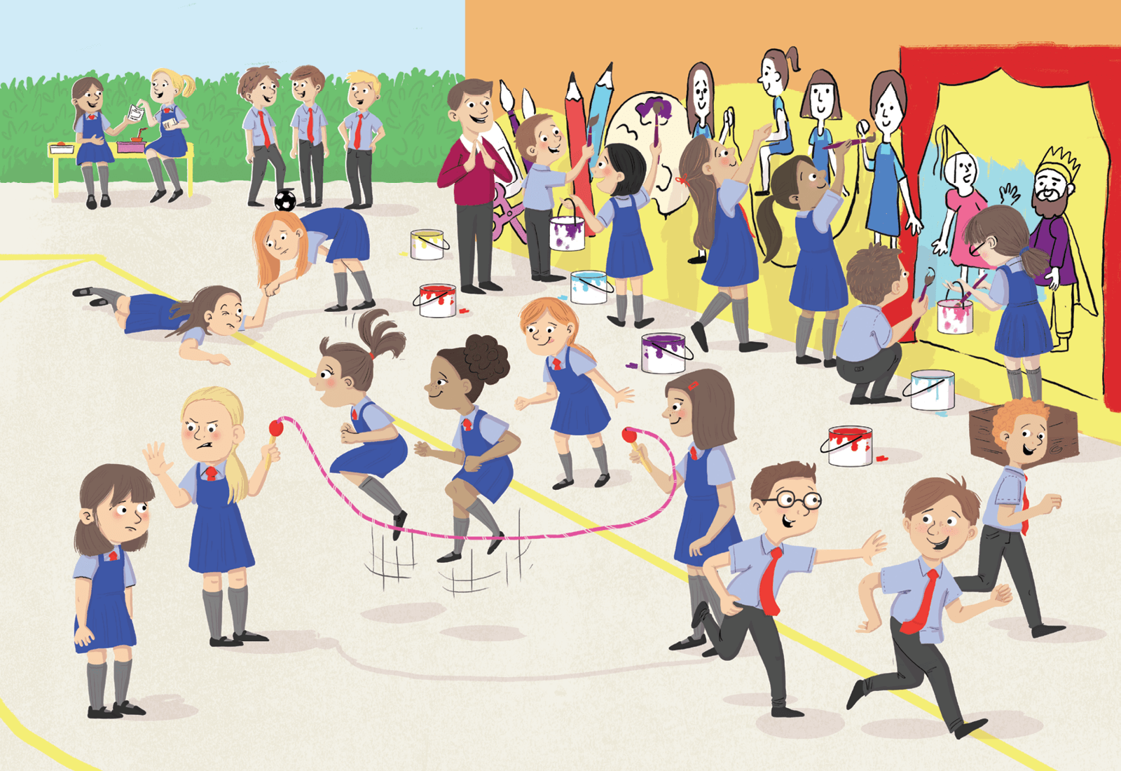
Class | Second Class | Theme | Myself
Unit | 2 | Subtheme | My friends
Vocabulary | Tier 1 examples: schoolyard, mural, paint, skipping, accident, bench,  teacher, game, upset, football  Tier 2 examples: nutritious, discussing, support, debate, pleasant,  supervising, popular  Tier 3 examples: compliment, considerate, trustworthy, respectful
Lesson resources | Multimedia links

Fortnightly plan
Lesson 1 | Digital poster (Explore mode): Talk and discussion  Digital poster (Story mode)  Who says?  Pair talking task: Turn and tell  Blurt it out! | Lesson 3 | Digital poster (Explore mode): Talk and discussion  Group talking task: Best buddies?  Digital poster (Activity mode): Choose the activity  Storytime  Group talking task: What Would You Do If …
Lesson 2 | Digital poster: Recap  Digital poster (Question mode)  Listen and say  Oral recount  Talking tennis | Lesson 4 | Digital poster (Label mode)  Digital poster (Poem mode): With a Friend  Group talking task: Imaginary friend

Lesson 1

Digital poster (Explore mode): Talk and discussion
Before revealing the poster, introduce the theme by playing the link to the song and lyrics of ‘You’ve got a Friend in Me’ from Toy Story (https://www.youtube.com/watch?v=zIYOJ_hSs0o). Ask the children the following questions:
- What is this song about? (Friendship)
- Listen again and this time, see what words you can hear/see that tell you it is about friendship (There isn’t anything I wouldn’t do for you; stick together; love you; me and you; our friendship will never die)
- Did you hear another word for a friend in the song? (Pal)
- Can you think of any other words we can use for a friend (Buddy, chum, mate)
- Look at the images in the video – what are the friends doing that tell you (depict) they are friends? (Smiling, standing together, hugging, arms around each other, playing together, helping each other out, having fun, playing tricks, joikng, feeling relaxed)
- Sing along as the song is played. When you hear a friendship word/phrase, turn to the person beside you and shake hands or high-five them.

Go to the Explore mode of the poster. Ask the children the following questions:
- Where are the children?
- Who are they with? (Friends, classmates)
- What games are they playing/activities are they doing? (Skipping, playing tag, painting a mural, chatting, sharing lunch, etc.)
- What games do you like to play with your friends?
Zoom in on the three boys chatting with a football.
- Do you think these boys are friends?
- How do you know they are friends? If they are friends then they are friendly with each other.
- Would you say that their friendship is strong? Why? (They are interested in the same pastime; they are having a conversation; they are enjoying each other’s company.)
Zoom in on the two girls eating lunch on the bench.
- Do you think these girls are friends?
- How do you know they are friends? If they are friends then we can say that they are friendly with each other.
- Would you say that their friendship is strong? Why? (They are sharing lunch together; they are having a conversation; they are enjoying each other’s company.)
Zoom in on the two girls on the bottom left side of the poster. Ask the children the following questions:
- Do you think these girls are good friends? Why not?
- Which girl is being unfriendly? Why?
- A good friend is NOT … (mean, unkind, unfriendly, uncaring, inattentive, disloyal, disrespectful, thoughtless, does not exclude someone from a game, never brags, etc.)

Digital poster (Story mode)

Play either the Story mode 1 (starters) or Story mode 2 (flyers) for the class, depending on the ability level.

Who says?
Ask children to listen to the following comments and guess which of the children in the poster is saying each comment.
- You are doing a really great job here! (Praising)
- What colour do you think I should paint the background? (Asking for advice)
- I hope everyone enjoys the mural (Eager to please)
- Would you like some of my …? (Sharing)
- I agree, they are definitely the best team. (Agreeing with one another)
- Can I help you? (Offering to help.)
- I’ve caught you!/Higher, higher! (Having fun)
Pair talking task: Turn and tell
Organise children in pairs. Ask them, what can we learn about being friends from what the children are saying/doing? (Friends like to spend time together, listen to each other, share stories, give advice, help one another, praise/compliment each other, have fun together, run, jump, play sport, do projects, skip, listen, talk, play together, can count on each other, have a lot in common, etc.)
Ask the children to turn to their partner and pay him/her a compliment, e.g. I really like your …; I think your … is …; I think what you did was …;
Next, ask children to turn and tell their partner what they like to do with their friends, e.g. I like to … with my friends. Children then share what their partners told them with the rest of the class, e.g. My partner likes to … with his/her friend.
Blurt it out!
Ask each child in turn to complete the sentences:
My friend is … (kind, caring, helpful, trustworthy, attentive, thoughtful, considerate, loyal, respectful …)
When I am with my friend I feel … (happy, joyful, delighted, pleased, glad …)
Encourage the children to use as many describing words as possible.

Lesson 2

Digital poster (Story mode): Recap
Play either the Story mode 1 (starters) or Story mode 2 (flyers) for the children again. Make sure they understand all of the vocabulary.

Digital poster (Question mode)
Go to the Question mode of the poster. Listen to each question and discuss the answers with the children briefly.

Q1. | Where are the children?
Q2. | What time of day is it?
Q3. | What games are being played?
Q4. | What are the children with paintbrushes doing?
Q5. | Do you think the teacher is happy with the mural? Why do you think so?
Q6. | How do you think the girl feels about being told she can't join in the skipping game? Why do you think that?
Q7. | Why do you think the other girl doesn’t want her to join in the skipping game?
Q8. | Imagine you were in this schoolyard. Which activity would you be doing? Why?
Q9. | Do you prefer spending your lunchtimes indoors or out in the school yard? Why?
Q10. | If you were painting a mural on your school wall, what would you draw?

Listen and say
Ask the children, do we ever feel unhappy when we are with our friends? Read Small Quarrel by Allan Ahlberg for the class, asking them to think about when a friend may make us unhappy.

Small Quarrel

Allan Ahlberg
She didn’t call for me as she usually does.
I shared my crisps with someone else.

I sat with someone else in assembly.
She gave me a funny look coming out.

I put a pencil mark on her maths book.
She put a felt pen mark on mine.

She moved my ruler an inch.
I moved hers a centimetre.

I just touched her P.E. bag with my foot.
She put the smallest tip of her tongue out.

She dipped her paint brush in my yellow.
I washed mine in her paint water.

She did something too small to tell what it was.
I pretended to do something.

I walked home with her as usual.
She came to my house for tea.

Now ask children the following questions:
- Do you know another word for quarrel?
- Why do you think the poet called this poem a small quarrel?
- What do you think the quarrel was about?
- Why do you think the poet didn’t tell us this?
- What words best describe the behaviour of the friends when they were not being kind to one another? (e.g. mean, nasty, unkind, uncaring, thoughtless …)

Oral recount
Ask the class, have you ever had a quarrel with a friend? When? Why? How did you feel? What happened in the end? Encourage children to share their recounts in pairs.

Talking tennis
Have children move around the classroom until they find a new friend who has something in common with you, e.g. you live in the same area, you like the same TV programme, you both have the same favourite pastime, have a love of animals, have the same pet, like the same colour, have a birthday in the same month, have the same favourite food, etc.
Have each child tell the class what they have in common. Pairs then stand and face each other, with each child in turn saying one thing that a good/bad friend would do. The winner is the person who can keep going longest, e.g.
A good friend is someone who shares nice things with you.
A bad friend is someone who talks about you behind your back.

Lesson 3

Digital poster: (Explore mode) Talk and discussion
Go to the Explore mode with children again. Ask the class:
- Which children do you think are best friends? Why?
- Do you think the children who are skipping are good friends?
- Which children do you think are better friends – the children who are painting the wall or the children who are playing tag? Why?
- Are all the children good friends? Can you see anyone who is a bad friend?

Group talking task: Best buddies?
Organise children in pairs or groups of three, and encourage them to choose one pair/small group of children from the poster. The groups then recreate that part of the poster as a still image and give their image a title.
Each group presents their still image to the class. One by one, tap each individual in the image on the shoulder. The child who has been tapped then tracks their character’s thoughts aloud, e.g.
Pair chosen: Girl helping friend who has fallen.
Image title: A helping hand.
Thought-tracking – girl on the ground: ‘Oh dear, I think I have cut my knee. This is so scary and painful. It’s good that my kind and caring friend is here to help.’
Thought-tracking – helpful friend: ‘Here, let me give you a hand/help you up. It will be all right. We can go and get a plaster for your sore knee and soon you will feel a whole lot better.’

Digital poster (Activity mode): Choose the activity
Go to the Activity mode of the poster. Ask children to choose the lunchtime activities from the list given. Briefly discuss the reasons for their decisions.
The activities listed are:
Doing homework, skipping, eating lunch, gardening, playing ball games, dancing, reading, scuba diving, playing running games, exercising, talking to my friends, watching a movie

Storytime
Play the story Frog and Toad are Friends by Arnold Lobel for the class: https://www.youtube.com/watch?v=OWIwUGAJs2U. After, ask the class the following questions:
- What did Toad do for Frog that showed he was a good friend?
- Would you say Frog and Toad were good friends or best friends? Why?
- What would you do to make your friend feel better?

Group talking task: What would you do if …?
Organise children in groups and present them with a friendship dilemma. Ask them to discuss and decide in their groups what they should do in each scenario. Examples are given below.
- Example 1: Emily’s birthday party is on Saturday. She is your best friend and you are invited to the party. However, she has not invited Aimee, who is also good friend of yours, because she doesn’t like Aimee. What should you do?
- Example 2: Mark is playing with his skateboard at home when his friend Peter comes over. Peter wants to have a go on the skateboard because he doesn’t have one of his own. Mark shares the skateboard with Peter, but Peter won’t give it back to him because he is having so much fun. What should Mark do?

Lesson 4

Digital poster (Label mode)
Go to the Label mode of the poster. Review the vocabulary. Have children take turns dragging the labels onto the correct location in the poster.

Digital poster (Poem mode): With a Friend

Go to the Poem mode of the poster and play the poem With a Friend.

With a Friend
by Vivian Gouled

I can talk with a friend
and walk with a friend
and share my umbrella
in the rain.
I can play with a friend
and stay with a friend
and learn with a friend
and explain.
I can eat with a friend
and compete with a friend
and even sometimes
disagree.
I can ride with a friend
and take pride with a friend.
A friend can mean
so much to me!

Group talking task: Imaginary friend

Organise children in groups of four. Give one child in each group a piece of paper. Each child carries out one of the instructions below, then passes the paper to the next child in the group for the next instruction, and so on until they have created an imaginary friend.
- Draw an outline of your friend.
- Write in adjectives to describe your friend.
- List/draw things you like to do with your imaginary friend.
- Describe how you feel when you are with your imaginary friend. Put in symbols/draw emojis to express these feelings.
- Give your friend a name.
Ask the group to recount to the rest of the class an adventure they had with their friend.

