Class | 2nd Class | Theme | Holidays
Unit | 16 | Subtheme | Heroes and villains
Unit genre | Narrative
Vocabulary | 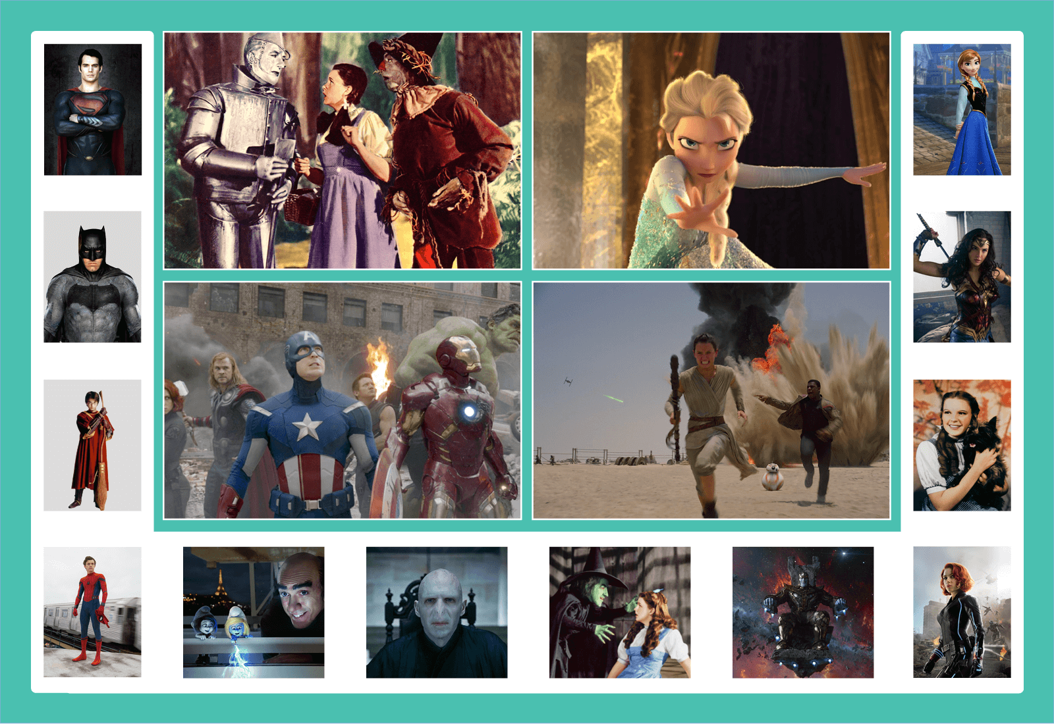  Tier 1 examples: heroes, villains, ordinary, super power, skills  Tier 2 examples: character, heroic, villainous, despite, courage,  wit, menacing, fiercely, hardship, struggle, inspire  Tier 3 examples: radioactive, sorcerer, fictional
Lesson resources | Multimedia links
Element | Learning outcome | The child should be able to …
Communicating | LO 1 | Actively listen and attend with interest to the Story mode.
 | LO 2, 3 | Use appropriate intonation when reciting a poem  Use language to work collaboratively; share outcomes with others.
Understanding | LO 4 | Understand sentence completion and ordering, e.g. Superhero sentence scramble
 | LO 5, 6 | Acquire and understand new vocabulary related to the topic of heroes and villains  Develop phonological awareness, e.g. onomatopoeia
Exploring and using | LO 9 | Ask and answer questions, e.g. circle time teasers.
 | LO 12 | Use playful language, e.g. Aunt Betty’s gear and gadgets.
 | LO 13 | Identify their own favourite heroes and give reasons why they are their favourites

Fortnightly plan
Lesson 1 | Digital poster (Story mode)  Digital poster (Explore mode): Talk and discussion; Superhero song  Pair talking task: Hero favourites | Lesson 3 | Digital poster (Explore mode): Talk and discussion  Guess who!; Circle time teasers  Digital poster (Activity mode): Multiple choice questions; Bam, Wham, Kapow!
Lesson 2 | Digital poster (Story mode): Recap  Digital poster (Question mode)  Pair talking task: Superhero sentence scramble; opposites chant | Lesson 4 | Digital poster (Label mode)  Digital poster (Poem mode): Auntie Betty Thinks She's Batgirl  Auntie Betty’s gear and gadgets

Lesson 1
Digital poster (Story mode) LO 1
Play either the Story mode 1 (starters) or Story mode 2 (flyers) for the class, depending on the ability level.

Digital poster (Explore mode): Talk and discussion LO 5, 6, 7, 10, 14
Go to the Explore mode of the poster. Spotlight the image third from the right on the bottom of the poster. Elicit/introduce the characters in the poster. Ask children the following questions:
- Are the two people in the picture the same? How are they different? [Focus on physical features, clothes, traits, colour and appearance: e.g. witch, hag, bright, dark, ugly, pretty, sharp, pointy, lumpy, angular, evil, wicked, nasty, hateful, unkind, unfriendly, etc.]
- These are people who feature in a story. We call them characters. Are characters real people? (No, they are fictional)
- We find characters in stories. Some are good characters and others are bad. What words do we use for good/bad characters in a story? (Hero/villain)
- Explain what a hero/villain is. (A person who shows great courage and is admired for his/her achievements; an evil person who opposes a hero)
- How could we describe someone who is very brave? (Heroic)
Spotlight the image of Batman. Ask the following question:
- Would you say that Batman is a hero? What qualities does this character have that show us he is a hero? (adjectives: brave, caring, kind, confident, considerate, courageous, daring, fearless, strong, tough, adventurous, heroic, unafraid, noble, epic, persevering; nouns: a hero shows courage/bravery; performs kind acts; verbs: a hero fights/saves/rescues/defeats)
Spotlight Superman. Ask the following questions:
- Would you say that Superman is a hero? Is he a hero like Batman? (He is a superhero – someone who has special powers which are used to help other people)
- What special powers does Superman have? (e.g. power of flight, superhuman strength, X-ray vision, speed, enhanced hearing)
- What have heroes and superheroes in common? (They help others, wear costumes, show courage/bravery)

Play the Superhero Song for the class. Encourage them to perform appropriate actions: https://www.youtube.com/watch?v=Py4fhsx3Ct4
Emphasise superhero vocabulary:
Nouns: superpowers, trouble, heroes, tower, trouble, city streets, tower, cape, mask, gloves
Verbs: fly, stomp, roar, lasso, blast off, run, climb, sneak, glide
Phrases: save the day/soaring through the clouds

Spotlight on Lord Voldemort. Ask the following questions:
- Would you say that Lord Voldemort is a hero? Why not? What qualities does this character have that show us he is a villain? (e.g. bad, mean, evil, horrible, cruel, scary, spooky, ugly, wicked, weird, monster, revolting, ruthless, gruesome …)
- What do villains in stories usually do?
Focus now on the whole poster. Ask the following questions:
- Can you name the heroes/villains on the poster? (Superman, Dorothy (TinMan/Scarecrow),Elsa, Anna, Batman, The Avengers (Captain America, Iron Man, Hulk, Thor, Black Widow), Star Wars (Rey, Finn), Wonder Woman, Harry Potter, Spiderman, Smurfs, Gargames, Lord Voldemort, Wicked Witch of the West, Thanus, Black Widow)
- Encourage some individual children to introduce characters to others who may not be familiar with them (scaffold children to include information about the name, qualities, powers, actions, vehicles, equipment used by the character). Which are heroes/superheroes/villains? How do you know?

Pair talking task: Hero Favourites LO 13
Organise the children in pairs. In turn, each child shares with their partner what they know about ONE of the characters in the poster:
- Which is your partner’s favourite/least favourite character? Why?
- Which character would your partner like to be? Why?
- Report your findings to the class.

Lesson 2
Digital poster (Story mode): Recap LO 1
Play either the Story mode 1 (starters) or Story mode 2 (flyers) for the children again. Make sure they understand all of the vocabulary.

Digital poster (Question mode) LO 8, 9, 13, 14
Go to the Question mode of the poster. Listen to each question and discuss the answers with the children briefly.

Q1. | Which movie is shown in the first large photograph on the left?
Q2. | What are Rey and Finn doing in the Star Wars photograph?
Q3. | Who is the hero in the top-left photo?
Q4. | Who was the villain in The Wizard of Oz?
Q5. | What made Elsa overcome her fears in Frozen?
Q6. | How did Spider-Man get his super powers?
Q7. | Can you name three of The Avengers?
Q8. | Why do you think people enjoy stories about heroes and villains?
Q9. | What is your favourite hero story?
Q10. | Who do you think is the worst villain? Why?

Pair talking tasks LO 4, 5, 6, 7
Superhero sentence scramble
Model this activity with the whole class first, then organise the children in pairs and ask each child in turn to complete the sentence.
Superheroes Can/Wear/Are/Use …
- Superheroes can fly, climb, run, attack, save, rescue …
- Superheroes wear costumes, capes, masks, gloves/gauntlets, boots, helmets, rigs, suit of armour …
- Superheroes use equipment/gadgets/tools, vehicles – batmobile, spidermobile, hulkcopter, motor cycle, tank, weapons, shields, wand, sword/sabre, repellent spray, bow and arrow, lasso of truth …
- Superheroes are brave, caring, kind, confident, considerate, courageous, daring, fearless, strong, tough…
To make this task more complex, take some of the completed sentences and jumble them up orally (or ask the children to do this). Ask the children to unscramble the sentences and put it back in the right order orally.

Opposites chant
Ask everyone to look at the poster. Say one word associated with the poster. Everyone in the class claps three times. One child chants a word which depicts the opposite meaning e.g.
Teacher: Good
Children: Clap three times
[Select one child to respond]
Child: Bad/evil/wicked/mischievous
More examples for opposites chant: dark/light, black/white; kind/mean, nasty; pretty/ugly; truth/lie; honest/dishonest, deceitful; safe/unsafe, truth/lie, etc.
This game can be played in pairs or small groups when the children are familiar with the format and the vocabulary.

Lesson 3
Digital poster (Explore mode): Talk and discussion LO 5, 6, 7, 9, 13
Go to the Explore mode with children again. Organise children in pairs.
Guess who!
Child A chooses one character – hero/superhero/villain from the poster – but doesn’t tell B which one.
Child B can ask five questions to guess which character A has chosen. Scaffold the children where necessary to ask questions about:

- Superpowers
- Clothing
- Equipment
- Vehicles
- Character traits

After a set amount of time ask the A to tell B who they were thinking of if B hasn’t already guessed. Ask a few children who their partner’s superhero was and how they guessed it.
The children then switch roles.

Circle time teasers
Organise the children to sit in circles in groups of four to six. There is one empty chair in the circle. This is the Question Chair. Each child in turn sits in the question chair and asks the group a question about the poster. Any member of the group may answer the question. When the question is answered correctly, the next child moves into the Question Chair.
Children are free to ask any question about what they see in the poster, e.g.
Child 1: Which person in the poster would you be most afraid of? Why?
Child 2: Can you see a character in the poster who is in a palace/desert/city/fantasy world?
Child 3: Who would you say is wearing the most brightly coloured costume in the poster?

Digital poster (Activity mode): Multiple choice questions; Bam, Wham, Kapow! LO 2, 5, 6, 13
Go to the Activity mode of the poster. Listen to each multiple choice question and discuss the possible answers with the children. Select the correct picture to move on to the next question.

Q1. | Which of these heroes is an alien?
Q2. | Which of these heroes is part of The Avengers?
Q3. | Which heroes teamed up to fight The First Order?
Q4. | Which of these heroes has a superpower?
Q5. | Which of these villains wants to defeat Harry Potter?

Zoom in on the image of Rey and Finn. Ask the children:
- What do you think is happening in this image?
- What do you think Rey is thinking?
- What do you think Finn is saying?
- What sounds could we hear if this was a movie?
- Talk about superhero/villain sounds (e.g. pow, bang smash, splat, bam, krunch, wham, splosh, boom, zap, kapow, boing …).
If appropriate, introduce the term onomatopoeia.

Group talking task LO 2, 3, 12
Organise the children in groups. Ask them to look carefully at the image of the Avengers on the poster.
Tell them to reproduce a still image of the scene depicted on the poster and give their image a title.
Ask them to bring their image to life by making each character speak speaks his/her thoughts aloud. Ask what they think will happen next using the superhero/villain sounds.

Lesson 4
Digital poster (Label mode) LO 6, 7
Go to the Label mode of the poster. Review the vocabulary. Have children take turns dragging the labels onto the correct location in the poster.

Digital poster (Poem mode): Auntie Betty Thinks She’s Batgirl LO 12
Go to the Poem mode of the poster and play the poem Auntie Betty Thinks She’s Batgirl by Andrea Shavick:

Auntie Betty Thinks She’s Batgirl
By Andrea Shavick

Auntie Betty pulls her cloak on
And the mask – the one with ears.
Almost ready, check the lipstick,
Wait until the neighbours cheer.
Through the window. What a leap!
She lands right in the driver’s seat.
Off she goes with style and grace
To make our world a better place.

Auntie Betty’s gear and gadgets LO 2, 3, 12
Organise the children in groups of four. Give each group an A3 sheet of paper. Each child in turn takes on the role of either the scribe or the illustrator during the completion of the task. Other assigned roles may include, for example: Materials organiser, encourager, questioner, word wizard, coordinator, presenter(s).
Design a costume (gear) OR a vehicle OR a tool/piece of equipment (gadget) for Auntie Betty to use when she goes with style and grace to make our world a better place.
When everyone is finished, organise group presentations of their work to the class.

