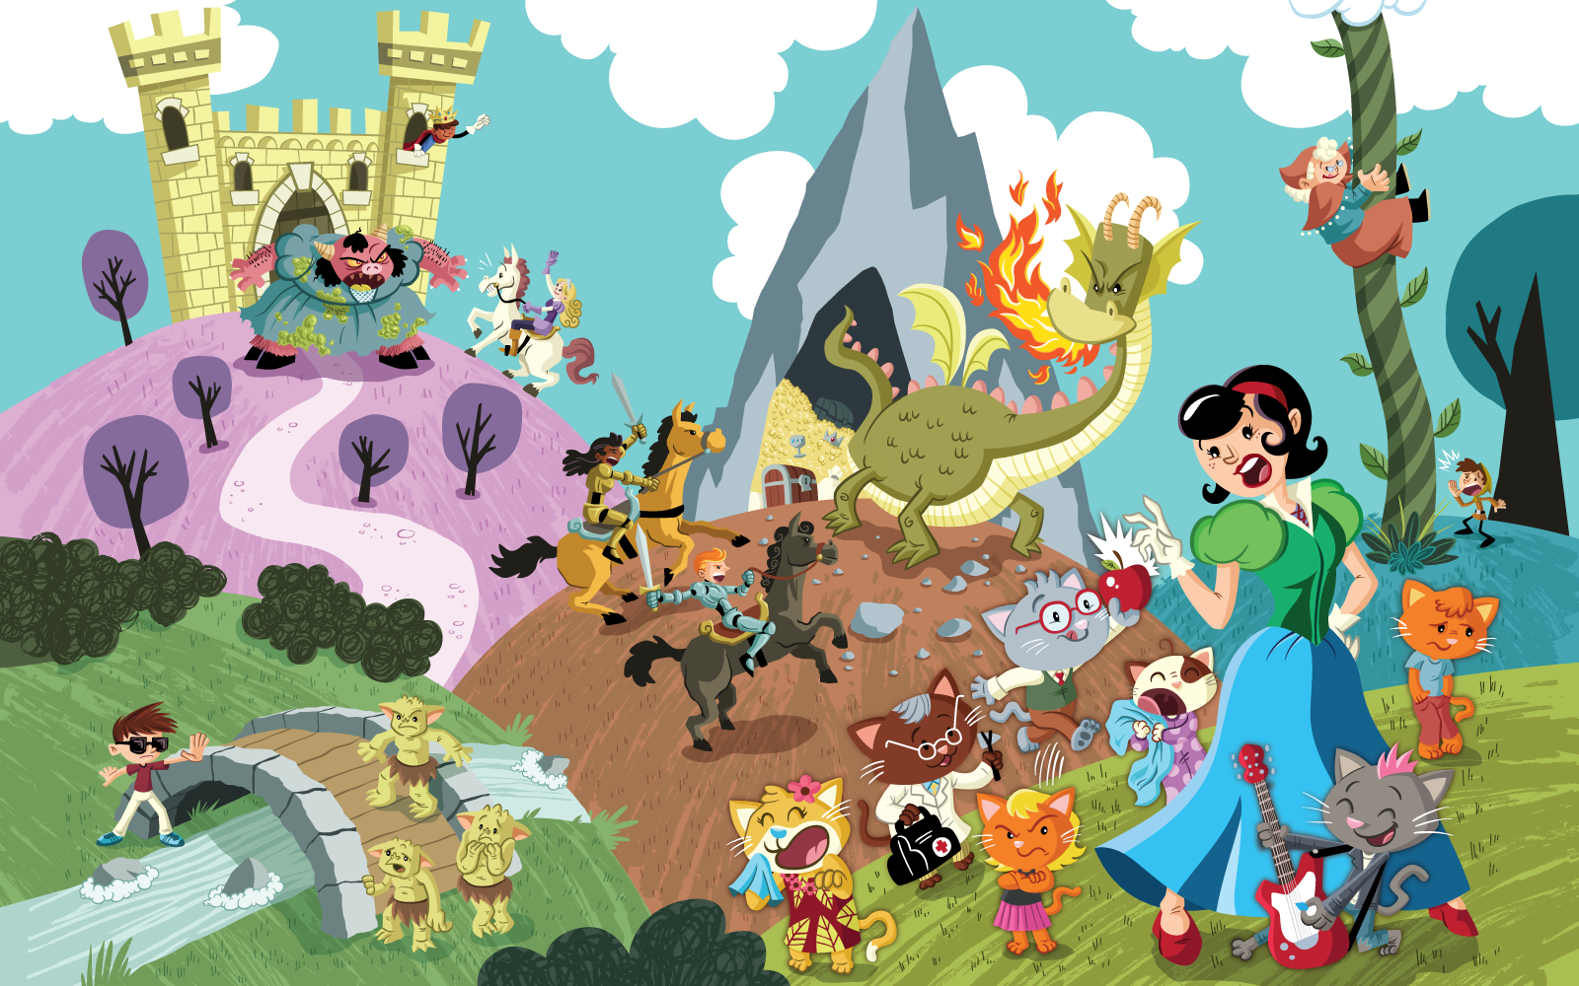
Class | 3rd | Theme | Fun and fantasy
Unit | 11 | Subtheme | Fantastic characters
Unit genre | Narrative
Vocabulary | Tier 1 examples: fantasy, character, brave, knight, princess,  beast, roar, fairy story, sword, beanstalk, troll, bridge, hero  Tier 2 examples: stereotype, traditional, mischievous, hideous, revolting,  lair, considerate, ferocious, courageous, brandishing, slay,  heroic, polite, jealous, gleefully, gruesome, confident, cunning  poisonous, meek, encouraging, bewitch, predictable
Lesson resources | Multimedia links

Fortnightly plan
Lesson 1 | Class discussion  Shrek trailer  Digital poster (Story mode) | Lesson 3 | Digital poster (Explore mode) – Talk and discussion  Fabricate a fairy-tale  Digital poster (Let’s Talk! mode): Stereotypes
Lesson 2 | Digital poster (Story mode): Recap  Digital poster (Question mode)  Create a character | Lesson 4 | Digital poster (Poem mode): ‘Rapunzel, Rapunzel’  Group improvisation: What happened next?
Lesson 1
Class discussion
Before showing the poster to the children, lead a brief classroom discussion about fairy-tales. What are they? What are their common features/themes? (E.g. good vs bad, magic/enchantment, adventure, royalty, animals that behave like humans, problem to be solved) Try and elicit the word ‘predictable’ from the children.
Incorporate some of the language associated with fairy-tales into this discussion (E.g. character, prince (charming), princess, queen, witch, dragon, giant, troll, goblin, fairy (godmother), stepmother, hero, heroine, sword, shield, horse/steed, treasure, gown, wand, castle, palace, once upon a time/in a land far, far away/they all lived happily ever after etc.).

Shrek trailer
Watch the trailer for Shrek: https://www.youtube.com/watch?v=V6X5ti4YlG8

Ask the children how is this similar to/different from the traditional depiction of fairy-tales.
- Similar – royal ball, castle, palace, princess, fairy godmother, princess locked in a tower, casting spells, carriage, magic mirror, poisoned apple …
- Different – hero is an ogre, prince charming is selfish, fairy godmother is wicked, princess is not beautiful, noble steed is a donkey …

Ask the children if they think this follows the predictable form of a traditional fairy-tale? Why not?
Explain that this is called a fractured fairy-tale – it changes traditional fairy-tales in unexpected ways.
Introduce the word ‘stereotype’ (a set idea that people have about what someone or something is like, which can be wrong). Explain that by depicting Shrek as a hero and Prince Charming as unpleasant and selfish, the film breaks the stereotype that ogres are nasty and evil, and princes are good and heroic.

Digital poster (Story mode)
Play either the Story mode 1 (starters) or Story mode 2 (flyers) for the class, depending on the ability level.
Encourage the children to consider/reflect on how the characters in each fairy-tale break the traditional form in unexpected ways, e.g. rescue from the tower – prince/princess roles and characteristics are reversed, knights are male and female, Three Billy Goats Gruff – trolls are scared, not scary

Lesson 2
Digital poster (Story mode): Recap
Play either the Story mode 1 (starters) or Story mode 2 (flyers) again. Make sure they understand all of the vocabulary.

Digital poster (Question mode):
Go to the Question mode of the poster. Play each question and discuss the answers with the children briefly.

Q1. | Look inside the dragon's cave. What can you see?
Q2. | Who is riding to rescue a prince?
Q3. | Who is stopping the trolls from crossing the bridge?
Q4. | Which cat would you name Medico? Why?
Q5. | How do you think Jack's mother felt while she was climbing the beanstalk? Why do you think that?
Q6. | Look at Snow White. Describe how you think she is feeling.
Q7. | What do you think will happen to Jack's mother at the top of the beanstalk?
Q8. | Which character did you find most surprising? Why?
Q9. | Think of another fairy story and suggest how to change the characters' roles.
Q10. | What do you think the illustrator is trying to say about the role of boys, girls, men and women?

Pair talking task: Create a character
Focus in turn on the beast/troll/dwarves/billy goats in the poster. Talk about the clothes they are wearing.
Divide the children into pairs and tell them they are going to create a new fairy-tale character and design an outfit for that character. One child has the paper and colours to draw the picture while the other child gives instructions. When they are finished, the children can take turns showing their picture to the class and talking about their character. Encourage them to think about and describe their character’s personality as well as their appearance/clothes. (E.g. Our character is called …/ Our character has … / Our character is wearing …/ Our likes/dislikes…/ Our character can…/ Our character is …because…)

Lesson 3
Digital poster (Explore mode): Talk and discussion
Go to the Explore mode of the poster. Focus on Fairy-tale settings and ask the children the following questions:
- What do we call the place where a fairy-tale happens? (the setting)
- What settings can you see in the poster? (bridge, beanstalk, castle, cave, clouds, etc.)
- What other settings often feature in fairy-tales? (kingdom, tower, forest, cottage, palace, etc.)
- How does the setting influence the story? (E.g. royal characters, brave adventures, epic journeys, scary happenings, etc.)

Pair talking task: Fabricate a fairy-tale
Tell the class that they are going to switch the characters and settings in the poster to see what happens! Divide the children into pairs and tell them to choose one of the characters in the poster. Ask them to place that character in a different setting, then tell a new fairy-tale outlining what happened. E.g.
- Jack in the Jungle
- The Billy Goats Gruff on the Beanstalk
- The Prince Trapped Under the Bridge
- The Troll in the Tower
- The Dragon in the Forest

Remind them of the elements common to fairy-tales and write them on the board, e.g. special language (once upon a time/in a land far, far away/they all lived happily ever after) good versus evil; a good character who is in trouble and a bad character who needs to be overcome; a magical helper /spell; animals that act like humans; a problem to be solved; a lesson to be learned; often involves royalty

Tell the children to share their story with another pair. Ask them which they feel is better – their fabricated fairy-tale or the traditional version of the fairy-tale? Why?

Digital poster (Let’s Talk! mode): Stereotypes
Go to the Let’s Talk mode of the poster. Show the children the images:

Image 1: Female mechanic
Image 2: Young boy washing dishes
Image 3: Business man on a skateboard
Image 4: Two older men playing video games
Image 5: A male nurse

Encourage the children to reflect on stereotypes and how it is important to remember that everyone is different. They should think about how people can behave differently to how we might expect.
Lesson 4
Digital poster (Poem mode): ‘Rapunzel, Rapunzel’
Go to the Poem mode of the poster and play the poem ‘Rapunzel, Rapunzel’ by Kenn Nesbitt:

Rapunzel, Rapunzel
by Kenn Nesbitt

‘Rapunzel! Rapunzel! You’ve cut off your hair!
Your billowing tresses are no longer there.
That mohawk you’re sporting is spiky and pink.
I’m really not certain just what I should think.’

‘I came here expecting to clamber a braid,
ascending your tower to come to your aid.
Instead I have suffered the greatest of shocks
to find that you’ve cut off your lovely blonde locks.’

‘Prince Charming, Prince Charming,’ Rapunzel replied,
‘I have no intention of being your bride.
We will not get married. We will not elope.
I’ve cut off my hair and I’ve braided a rope.’

‘You came here to visit me once every day,
and promised that soon you would take me away,
but you were too clueless to even concieve
of cutting my hair off so we could just leave.’

‘I cannot believe you were such a big dope.
I come and I go as I please with my rope.
And so, I’m afraid I can’t give you my hand.
In spite of the fabulous wedding you planned.’

From then on Rapunzel was known through the land.
She toured the world in a rock and roll band.
And silly Prince Charming, with rocks in his head,
rode off and got married to Snow White instead.

Divide the children into groups of three and have them speak the poem, with each child taking a different role (i.e. the Prince, the Princess or the Narrator)
Afterwards ask them the following questions:
- What does Rapunzel mean when she says to Prince Charming ‘I can’t give you my hand’?
- What rhyming words can you hear in the poem?
- What synonyms for hair/climb/plait/going up/help/idiot does the poet use?
- What are the traditional/typical fairy-tale elements in the poem? (E.g. princess, Prince Charming, tower, bride, wedding; language, e.g. billowing tresses, clamber a braid, ascending your tower)
- What things in the poem are surprising and not something you would usually associate with fairy-tales? (E.g. mohawk which is spiky and pink, silly, clueless prince, clever princess who saved herself and toured in a rock and roll band)
- How is the ending of the poem different to the traditional fairy-tale?

Group improvisation: What happened next?
Divide the class into groups. Tell each group to choose any one of the scenes from the traditional fairy-tales depicted on the poster and make a still image of the scene.Then, ask them to bring their scene to life and to improvise what they think happened next.

