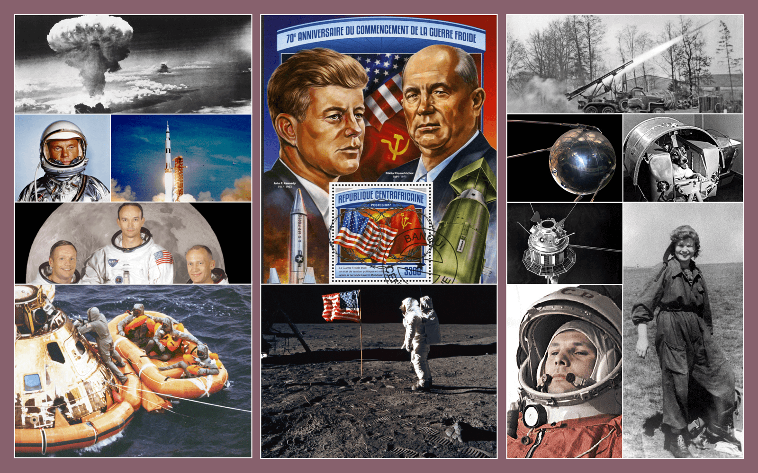  Class | 4th | Theme | Space and technology
Unit | 1 | Subtheme | The space race
Unit genre | Recount | Oral text type |  | Oral recount
Vocabulary | Tier 1 examples: bombs, weapons, astronauts, launched, satellite, orbit, demonstrate, president, successful  Tier 2 examples: allies, superiority, weaponry, military, technology, declared, triumphant, mistrusting  Tier 3 examples: Soviet Union, cosmonauts
Lesson resources | Multimedia links

Fortnightly plan
Lesson 1 | Digital poster (Story mode)  Digital poster: Talk and discussion  Pair talking tasks: Word play  Pair/group talking task (Oral recount): Space race sequence | Lesson 3 | Digital poster (Explore mode): Talk and discussion  Pair talking task: Meet Valentina  To be or not to be: An astronaut
Lesson 2 | Digital poster (Story mode): Recap  Digital poster (Question mode)  Animals in space | Lesson 4 | Digital poster (Let’s Talk! mode): Why space exploration is so important  Group talking task: Living on the moon: Science or science fiction?

Lesson 1

Digital poster (Story mode)
Play either the Story mode 1 (starters) or Story mode 2 (flyers) for the class, depending on the ability level.
Digital poster: Talk and discussion
Ask students the following questions:
- The title of this poster is The Space Race. Think about the word ‘race’. Who/what do we normally associate with that word? (Athletes, runners, horses, cars, greyhounds). What are they doing? (Competing, trying to win/to be first/the fastest). What do you think the people in The Space Race poster are doing? (Competing to be the first to achieve something related to space).
- What are they trying to achieve (successfully reach/attain a goal/objective)? (To be fastest/best/first/greatest/superior)
- What do we call those involved in a race? (Competitors, contestants); What do we call those watching a race? (Spectators)
- When someone is fastest/first in a race, what do we call that person? (Winner, champion, victor). A winner is someone who has won the race. How do you think that person feels? (Someone who has won feels … joyful, proud, victorious, triumphant, jubilant, etc.)
- What term is used for someone who nearly wins? (Runner-up)
- Explore other words associated with ‘race’. (e.g. lead(er), runner-up, pack, overtake, head start, lightning speed, neck and neck, sprint, finish line, dead heat, false start, drop back, starting block, under starter’s orders, etc.)
Organise students in pairs. Each child turns to recount to their partner a time when they were involved in a race, either as a competitor or as a spectator. Encourage the students to use between three and five complete sentences.

Pair talking tasks: Word play
Organise students to complete the tasks below in pairs, groups or as a whole class, as appropriate.
- How many words can you think of that rhyme with ‘race’? (e.g. race, face, lace, brace, grace, chase, place, trace, case, base, etc.) Each partner in turn contributes a word. The winning pair is the pair that generates most rhyming words. Draw students’s attention to the fact that sometimes the sound is represented with a ‘c’ and sometimes with an ‘s’.
- How many words can we make using some of the letters in the word ‘race’? (e.g. ear, ace, car, are, arc, era)
- What other meanings are there for the word ‘race’? (A group of people who share similar characteristics, e.g. physical, cultural, language, history. Human race – all of the living humans on Earth; we are all members of the human race)
- Can you think of idioms containing the word ‘race’? (e.g. a race against time – to try to accomplish something in a very short time; one horse race – where one of the competitors is vastly superior and most likely to win; slow and steady wins the race – if you work slowly and methodically you are more likely to succeed than if you rush – from Aesop’s The Tortoise and the Hare fable)

Pair/Group talking task (Oral recount): Space race sequence
Ask students to look closely at the images on the poster. Decide together, as a class, on the sequence of events in the space race. Number the images about the space race in sequence – which picture comes first, next, then, after, etc.
Organise students in pairs or groups. Within their pairs or groups, students must prepare to recount the story of the space race to someone who doesn’t know about it in just four or five sentences.
Encourage the students to combine some of the images into one complex sentence (e.g. Not only was the Soviet Union the first country in the world to launch an animal into space successfully, they also succeeded in putting the first human, Yuri Gagarin into space as well as the first woman). Pairs or groups then present their recounts to another group, class, or teacher.

Lesson 2

Digital poster (Story mode): Recap
Play either the Story mode 1 (starters) or Story mode 2 (flyers) again. Make sure students understand all of the vocabulary.

Digital poster (Question mode)
Go to the Question mode of the poster. Play each question and discuss the answers with the students.
Q1. | What year did the Second World War end?
Q2. | Who seemed to be winning the space race at first?
Q3. | What was the name of the American president who announced the plan to be first to land a human on the moon?
Q4. | Why did the Soviet Union and the United States carry on developing weapons after the Second World War?
Q5. | Why did the Soviet Union want to send Laika into orbit?
Q6. | Why was it particularly worrying for the Americans when Yuri Gagarin went into space?
Q7. | Where did the Apollo 11 crew land when they returned to Earth?
Q8. | Do you think people in the Soviet Union felt the same about the Apollo 11 landing as people in America did? Why?
Q9. | Which of the astronauts mentioned in the piece do you think was bravest, and why?
Q10. | Was the space race a good thing or a bad thing? Explain your ideas.

Pair talking task: Animals in space
Organise students in pairs. Spotlight the image of Laika, the dog on board Sputnik 2. Ask students the following questions:
- Can you remember the name of the dog sent by the Soviet Union into orbit? (Laika)
- American reporters gave the dog the nickname Muttnik. Why? (Mutt – a dog; on board Sputnik)
- What words could we use to describe this dog? (e.g. courageous, brave, bold, daring, heroic, plucky, intrepid, etc.)
Discuss with the class other animals that have gone into space (see these links for further info: https://www.nationalgeographic.com.au/space/animals-in-space.aspx; http://www.socialstudiesforkids.com/articles/worldhistory/animalsinspace.htm ).
Ask pairs to generate two or three interesting sentences about one animal in space, then share their information with another pair.

Lesson 3

Digital poster (Explore mode): Talk and discussion
Go to the Explore mode of the poster. Ask students the following questions:
- Valentine Tereshkova was the first woman to go into space. What do we call someone who is the very first to do something? (elicit as many vocabulary terms as appropriate: pioneer/leader/trailblazer/innovator/game-changer etc.)
- What qualities/characteristics/personality traits do you think pioneers/leaders/trailblazers have? Encourage students to justify their answers. Scaffold them to answer in the following format:
To be a leader, you must be brave because you will be facing the unknown; To be a trailblazer you must be adventurous because you will be trying things nobody else has ever tried to do before; To be be a pioneer you must be clever so you can think of brand-new ideas, etc.
Encourage students to name other historical figures who they consider to have been leaders/pioneers/trailblazers and to explain why they think this is.

Pair talking task: Meet Valentina
Spotlight the image of Valentina Tereshkova. Play this video clip about her journey into space: https://www.youtube.com/watch?v=qDlEQabKQ5U
Organise students in pairs. With their partners, students must generate five interesting questions they would like to ask Valentina if they were lucky enough to meet her (e.g. Why did you enjoy parachuting so much?; What inspired you to become an astronaut?; Were you afraid to fly solo?; Why do you think space travel needs the participation of women?; Did it bother you not to have a toothbrush?; Did you ever go into space again?; What did Earth look like from space?, etc.)
Pick one child in the class to take the role in the hotseat of Valentina Tereshkova. The other students take on the role of news reporters. Each child must introduce him/herself in role and ask a question about her journey into space (e.g. Good morning, my name is … and I represent the newspaper/TV station/magazine/online platform/website … I would like to ask you …)
Students swap roles and repeat.

To be or not to be an astronaut
Spotlight the image of the astronauts who landed on the moon. Play this video clip about their trip: https://www.youtube.com/watch?v=CbTaDOuSePk
Ask the students, would you like to be an astronaut? Students explain their answers: I would/would not like to become an astronaut because …

Lesson 4

Digital poster (Let’s Talk! mode): Why space exploration is so important
Go to the Let’s Talk mode of the poster. Play the podcast, ‘Why space exploration is so important’. Ask students the following questions:
- Millie thinks that space exploration is very important. What arguments does she make to support this point of view?
- Do you agree with Millie about the importance of space exploration despite its enormous cost?
- What arguments would someone who disagrees with Millie make?

Group talking task: Living on the moon – science or science fiction?
Spotlight the image of Buzz Aldrin taken by Neil Armstrong walking on the moon. Play the original footage of Neil Armstrong stepping on to the moon – https://www.youtube.com/watch?v=fz01MkVczjY
Ask students the following questions:
- What were the words used by Neil Armstrong when he first stepped on to the moon? (That’s one small step for man, one giant leap for mankind).
- What do you think he meant when he said that? (A big step forward for the human race as we discover new frontiers – places where we have never been before)
- What do you notice about the image of the astronaut on the moon and the other images on the left side of the poster? (The moon is very dark). What can you see on the bottom of this image? (Footprints made by the astronauts). Because there is no wind or rain, volcanoes or earthquakes on the moon, the footprints are likely to last a long, long time. (For more interesting facts about the moon, see https://www.natgeokids.com/au/discover/science/space/facts-about-the-moon/ )
- Speculate on what life on the moon would be like if we lived there, how it would be different from life here on Earth, and how humans and animals might have to adapt to survive. Generate a whole-class discussion on this when groups have had a chance to consider these questions.

