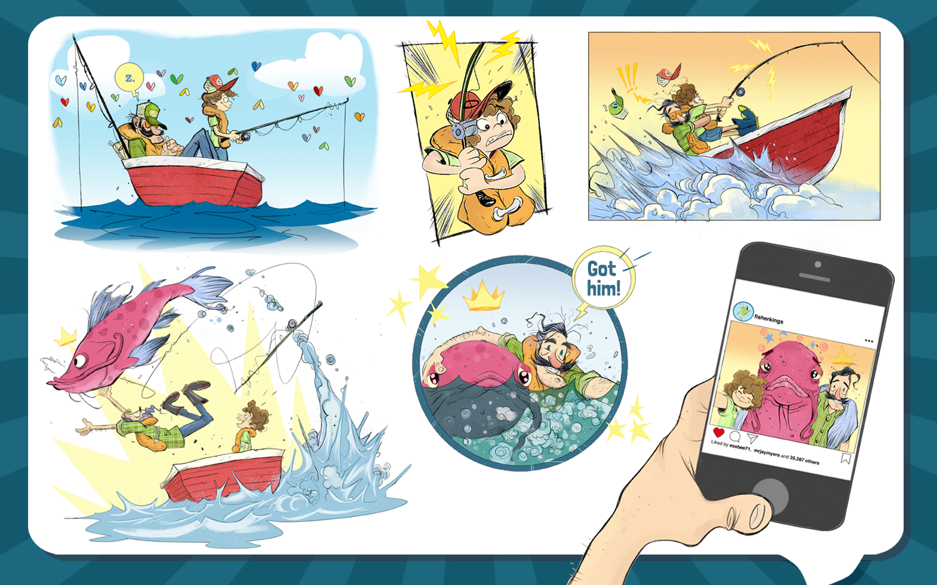
Class | 4th Class | Theme | Fun and fantasy
Unit | 14 | Subtheme | Tall tales
Unit Genre | Narrative | OL Text Type | Storytelling
Vocabulary | Tier 1 examples: adventure, bravery, monster, massive, amazing, selfie  Tier 2 examples: imaginary, tall tale, heroism, nail-biting, audacious, balmy, peril, gargantuan, concede, victorious, exaggeration, humorous  Tier 3 examples: narrative, genre, hyperbole,
Lesson resources | Multimedia links

Fortnightly plan
Lesson 1 | Digital poster (Story mode)  Digital poster (Explore mode): Talk and discussion  Tall tale features  Storytelling: Tall tale tennis | Lesson 3 | Digital poster (Explore mode): Talk and discussion  Pair talking task (Storytelling): Viewpoint
Lesson 2 | Digital poster (Story mode): Recap  Digital poster (Question mode)  Vocabulary and Word Study  Pair Talking Task: Stop Pulling my Leg | Lesson 4 | Digital poster (Let’s Talk mode): Tall tale flashcards

Lesson 1
Digital poster (Story mode)
Play either the Story mode 1 (starters) or Story mode 2 (flyers) for the class, depending on the ability level.

Digital poster (Explore mode): Talk and discussion
Go to the Explore mode of the poster. Ask students the following questions:
- What word is used in the poster story that tells us this is going to be a story? (Tale)
- What is a story? (An account of imaginary or real people and events told for entertainment). Can students think of another word for ‘story? (narrative)
- What forms of narrative/stories do you know? (e.g. fairy tale, folk tale, fable, myth, legend, mystery, science fiction).
- The narrative in this poster is called a Tall Tale. Why do you think it might be called this? (It is a story with events that are exaggerated and difficult to believe. It stretches the truth). Explain that tall tales are often found in American folk literature and are usually humorous with characters that perform unbelievable and heroic deeds
- Would you say it is a real or an imaginary account of what happened? Why? (It may have been a real fishing trip that the boy went on with his Grandad, but it had imaginary elements in it that couldn’t be true)
Explain the terms literal/figurative (literal – actual meaning; figurative - words and phrases with more imaginative meaning to give special effect). Give examples of figurative language from the poster story (e.g. nail-baiting adventure, the sea boiled and churned, powering through the waves like a rocket etc.)

Write the below list of tall tale features on the board:
  - story that may or may not be true but is hard to believe
  - story details are greatly exaggerated
  - contains lots of humour
  - has typical story elements of plot, character, setting, problem and resolution, BUT characters perform superhuman feats (achievements) involving courage and bravery
  - plot is action-filled, grabbing the listener’s/reader’s attention
  - resolution often involves heroic deeds

Play the story for the students again. Tell them that this time as they listen, they should try and identify these features. Explore how the story demonstrates these features. Consider, what parts of the story might be true? What parts of the story seem too unbelievable to be true? What parts of the story are funny/humorous?

Pair talking task: Tall tale features
Students in pairs watch the video clip of Paul Bunyan (https://www.youtube.com/watch?v=C-zKKoHvXn0).
What features of a tall tale can you identify in this story? Support students here to focus on both the oral stylistic and genre characteristics typical of Tall Tales. Students report back to the class.

Storytelling: Tall Tale Tennis
Tell students they are going to invent and share a tall tale with their partner. Each student in turn gives an account of a simple feat based in truth but greatly exaggerated (e.g. how many potatoes I ate with my dinner; the size of my dog; a heroic feat my sister/brother performed to rescue someone/an animal). Students continue sharing accounts back and forth for as long as they can. Invite some of the students to share a Tall Tale with the class.

Lesson 2
Digital poster (Story mode): Recap
Play either the Story mode 1 (starters) or Story mode 2 (flyers) for the students again. Make sure they understand all of the vocabulary.

Digital poster (Question mode)
Go to the Question mode of the poster. Listen to each question and discuss the answers with the children briefly.

Q1. | What is the weather like in this story?
Q2. | What happens to make the child feel less sleepy?
Q3. | Who wins in the battle between Grandad and the fish?
Q4. | What makes the boat zoom along fast?
Q5. | What might have made the waves rougher while Grandad was fighting with the fish?
Q6. | What would have happened if the child had dropped the rod as soon as the fish started pulling?
Q7. | Find three words the author uses to describe the size of the fish. Which do you think is most effective?
Q8. | How do you think the fish felt about its adventure? Describe it from the fish's viewpoint.
Q9. | Which part of the story do you think is funniest. Why?
Q10. | What clues do we get that the story might not be completely true?

Vocabulary and Word Study
If students have listened to Story 1 (starters) ask them the following:

- How is the fish described in the story? (monster of the deep, beast)
- Can you explain what the following mean: zooming like a rocket; clung on for dear life; felt like an age; didn’t look back; a likely story
- What language associated with technology and media can you hear in the story? (selfie; trending; social media; hashtag; youtube channel). Do you think those words/phrases were used when your grandparents were your age? Why?
- What words are used in the story to indicate that the fish is big? (mighty big; gigantic; enormous).

If students have listened to Story 2 (flyers) ask them the following:
- How is the fish described in the story? (terrifying monster of the deep, mighty beast, gargantuan creature)
- What words are used in the story to indicate that the fish is big? (mighty big; gigantic; enormous; gargantuan)
- What words in the story indicate that this is an exciting story? (e.g. epic, adventure, daring, peril, victorious)
- The storyteller uses many strong describing words/adjectives in this story. Can you remember any of them? (superhuman, astonishing, amazing, audacious, terrifying, powerful, extraordinary, determined, gargantuan, gigantic). What do these words tell us about the Tall Tale genre? (use of exaggeration)

Pair Talking Task: Stop Pulling my Leg
Tell students that exaggeration means describing something as more – better or worse – than it actually is. It is used to emphasise something. In stories, it is sometimes referred to as hyperbole. E.g.
- The cat was so thin it could slide through a keyhole
- I’m so hungry I could eat a horse
- We got a ton of homework last night
- I told her a million times not to do that

Write the below sentences on the board. In pairs, tell students to finish these sentences orally using exaggeration/hyperbole:
- The dog was so lazy that …
- The cheetah ran so fast that …
- The climate was so hot that …
- The food was so disgusting that …
- I was so tired that …

Lesson 3
Digital poster (Explore mode): Talk and discussion
Go to the Explore mode with students again.
Focus on the scene in the fourth picture. Ask students the following:
- Who are the characters in this scene?
- What is happening?
- How are the events in the scene exaggerated?
- How effective would this scene be without the exaggeration do you think? Why?

Pair talking task (Storytelling): Viewpoint
Tell students to choose ONE of the characters in the story – Grandad or the Fish. Ask them to retell the story from that character’s point of view.

To teach students about perspective in narrative, watch or read either of these resources:
Voices in the Park by Anthony Browne (https://www.youtube.com/watch?v=ohs-7ue_wdM)
One Inch Tall by Shel Silverstein (https://www.youtube.com/watch?v=uK1frBPCv_g)

With students explore how a story varies depending on who is telling it. Consider the use of pronouns when narrating in the first person (I) or third person (he/she).

Lesson 4
Digital poster (Let’s Talk! mode): Flashcards
Go to the Let’s Talk mode of the poster. Click on each flashcard to display a tall tale image to the class and ask them to discuss.

