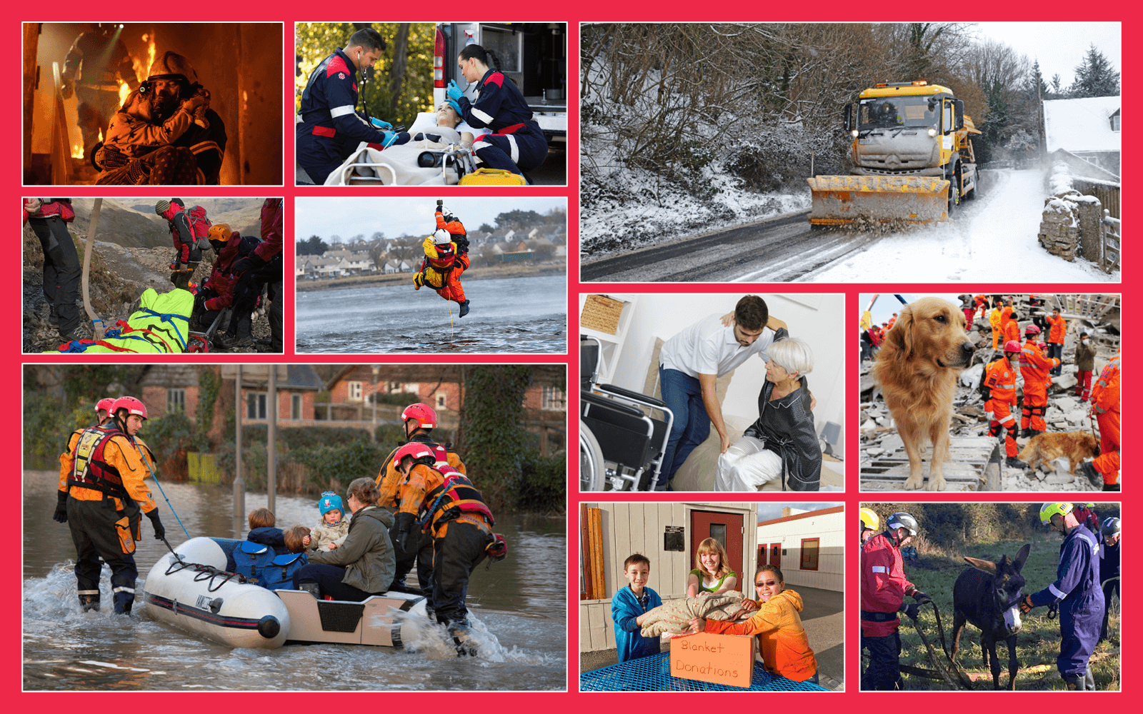  Class | 5th | Theme | Family and community
Unit | 1 | Subtheme | Communities in need
Unit genre | Recount | Oral text type |  | Oral recount/Interviewing
Vocabulary | Tier 1 examples: communities, emergency, volunteer, firefighter, hazard, snow-plough, grit, wounded, collapsed, charities, harness, rubble  Tier 2 examples: humane, undertake, arduous, volatile, terrain, paramedic, apparatus, compassionate, altruistic, humanitarian, conscientious
Lesson resources | Multimedia links

Lesson 1 | Digital poster (Story mode)  Digital poster (Talk and discussion)  Pair talking task: Who am I?  Pair talking task: Nice to meet you | Lesson 3 | Digital poster (Explore mode) – Talk and discussion  Pair talking task: Tell me why  Group talking task (Oral recount/interviewing): On the hotseat!
Lesson 2 | Digital poster (Story mode): Recap  Digital poster (Question mode)  Same difference | Lesson 4 | Digital poster (Let’s Talk! mode): The importance of people who help us  Small group talking task: A friend in need

Lesson 1

Digital poster (Story mode)
Play either the Story mode 1 (starters) or Story mode 2 (flyers) for the class, depending on the ability level.

Digital poster (Talk and discussion)
Ask students the following questions:
- What is common to all of the scenes depicted on the poster? (Everyone shown needs help)
- How is ‘need’ different from ‘want’? (e.g. A need is essential in order to thrive; a want is a desire to have something.)
- Explore words related to need, e.g. necessary, vital, essential, crucial, urgent, pressing, high priority.
- Name the people featured in the poster who provide vital services to the community (firefighters, paramedics, council workers, Civil Defence workers, care workers, charity volunteers, Irish Coast Guard, ISPCA/Dogs Trust workers, mountain rescue teams)
- Which of these names is a compound word? (Firefighter)
- Name the clothing and equipment you see in the poster. (e.g. fire retardant, heat resistant, waterproof, insulated, overalls, helmets, hard wearing, breathing apparatus, visor, gloves, elbow/knee pads …)
- How many titles/phrases can you make with the word rescue? (e.g. rescue service, attempt, mission, operation, patrol, party, team, to the rescue, come to the rescue, search and rescue)
- What is particular about all of these services? (they involve situations of high need – take risks, high alert, call outs, assess, stabilise, emergency, catastrophe, treacherous, dangerous, hazardous conditions)
- What words could we use to describe people who provide us with these crucial services? (Selfless, unselfish, altruistic, courageous, brave, heroic, valiant, caring, warm-hearted, concerned, generous, tender, gentle, considerate, compassionate, humanitarian, skilful, adept, competent, expert, deft, capable, efficient, cautious, thorough, painstaking, conscientious)
- List the actions which these jobs entail. (Rescue, carry, examine, remove, winch, move, plough, clear, assist, search, donate, assess, etc.)

Pair talking task: Who am I?
Zoom in on each image in turn. Ask students to think of a word (an adverb) to clearly describe each of the actions shown. (e.g. courageously, bravely, selflessly, skilfully, gingerly, warily, safely, cautiously, delicately, smoothly, ably, expertly, nimbly, thoroughly, completely, fully, ably, gently, exhaustively, meticulously, scrupulously, generously, graciously).
Model using some of the adverbs in a sentence, (e.g. The firefighter carries the distressed girl skilfully/safely; the paramedic examines the patient thoroughly; the Irish Coast Guard member winches the casualty ably/expertly/smoothly.)
Now ask students to choose one person in the poster, imagine they are that person, and explain what they are doing. This could be someone providing a service or someone who is receiving a service.
Encourage students to use at least one verb, one adverb, one noun and one adjective, but to include more if possible, e.g. I am a skilful firefighter who is gingerly carrying an unconscious casualty to safety; I am a compassionate care worker expertly assisting an unwell patient out of bed.

Pair talking task: Nice to meet you
Once again, ask students to choose ONE character from the poster. They begin to move around the classroom. On a signal from the teacher, each child turns to the classmate nearest to them. They should greet one another and share their profiles, e.g. My name is; I am a … My job entails … For example, the photo you see here shows me … and … you may notice that I need to wear/use/do … I love my work because … Repeat this until students have had an opportunity to speak to a number of their classmates.

Lesson 2

Digital poster (Story mode): Recap
Play either the Story mode 1 (starters) or Story mode 2 (flyers) again. Make sure students understand all of the vocabulary.

Digital poster (Question mode)
Go to the Question mode of the poster. Play each question and discuss the answers with the students briefly.
Q1. | Name two of Ireland’s emergency services.
Q2. | What methods are used to clear the roads of snow and ice?
Q3. | What do the rescue workers use dogs for?
Q4. | Discus the word ‘volunteer’ using two facts from the poster.
Q5. | Name two things that volunteers can do.
Q6. | Why might someone need help from a care worker?
Q7. | Choose one of the photos in this poster and describe in your own words what is happening in it.
Q8. | What things can you think of that might make a mountain rescue difficult?
Q9. | Look at the picture of a family being rescued in a flood. How do you think the different people in the picture are feeling?
Q10. | If you could work in one of the jobs shown, which would you choose and why?

Pair talking task: Same difference
Organise students in pairs. Explain that the people on the poster who help others are very similar in some ways – however, there are some differences between them also.
Ask students to work with their partners to identify as many differences as possible between the jobs these workers have.
Encourage students to use conjunctions (e.g. Some work in dangerous situations while others don’t; some operate in the air, however others work in water/in fire/on land/in homes; use different vehicles – some operate in a fire engine, whereas others are in a snow plough/helicopter/ambulance; some work with people but on the other hand others work with animals, etc.)
(Contrasting conjunctions include alternatively, but, however, instead, on the other hand, although, while …)

Lesson 3

Digital poster (Explore mode): Talk and discussion
Go to the Explore mode of the poster. Spotlight the image of the Search and Rescue (SAR) dog. Ask students the following questions:
- Where is this scene set? How do you know?
- What do you think might have happened?
- What words can we use for this situation? (Disaster, catastrophe, crash, calamity, fiasco, tragedy, etc.) What evidence for this can you see in the picture?
- What can you see in the foreground of the picture?
- Do you know what this particular type of dog is called? (SAR dog – Search and Rescue dog)
- Play this clip to learn more about SAR dogs – https://www.youtube.com/watch?v=NCIi8Cf_zCs. And visit the SARDA website to learn more about SAR dogs in Ireland http://sardaireland.com/why-use-dogs/how-are-dogs-trained/

Partner talking task: Tell me why
Why are SAR dogs important?
Scaffold the students in pairs to identify the most interesting thing(s) they learned about SAR dogs (e.g. their role, importance, type of dog, training, relationship with the handler). Encourage each pair of students to prepare an explanation for someone who doesn’t know what a SAR dog is and why these dogs are so important. Ask the students to then present their explanations to someone at home, younger students in the school, the principal, at assembly, etc.

Group talking task (Oral recount/interviewing): On the hotseat!
Organise students in groups of between four and five. One child in each group is in the hotseat taking the role of the dog in the disaster image on the poster. The other students take on the role of newspaper reporters asking the SAR dog questions about what is happening in the image. Students could rotate roles after each question until all students have had a chance to answer and ask questions. Together students will build an oral recount which explains the story of the image.
Encourage the students asking questions to use ‘who, what, when, where’ to get as much information as possible (e.g. What happened? Where did it happen? How did you feel? What did you do next? etc.) Encourage students answering the questions to use time words like first, then, after that, eventually and finally to give their answers structure. The final answers should conclude the story of what happened.

Lesson 4

Digital poster (Let’s Talk!) mode: The importance of people who help us
Go to the Let’s Talk! mode of the poster. Play the podcast.
- What is the podcast about?
- Explain the meaning of the word recognition as it is used in the podcast. (Public appreciation for something that someone has achieved/done vs. identification of someone because you met/saw that person before)
- What is an unsung hero? (Someone who does very good things but does not receive much recognition/appreciation for what has been done)
- What examples of unsung heroes can we see in the poster?
- Who do you think Suzanne Gannon most admires? Why?
- What sacrifices do volunteers often make?
- How do you feel about people who help communities in need? Why?
- What do you think life would be like without these unsung heroes?

Small group talking task: A friend in need
Ask students if they know the meaning of the proverb A friend in need is a friend indeed (i.e. when you are in need of help, a true friend is someone who is willing to show their friendship and compassion by acting to help you out). Give students examples of the types of things good friends do.
Organise students in groups of three or four. Each group must devise an improvisation of a fictitious situation, showing the actions of a friend who helps another friend out, thereby demonstrating the meaning of the proverb.

