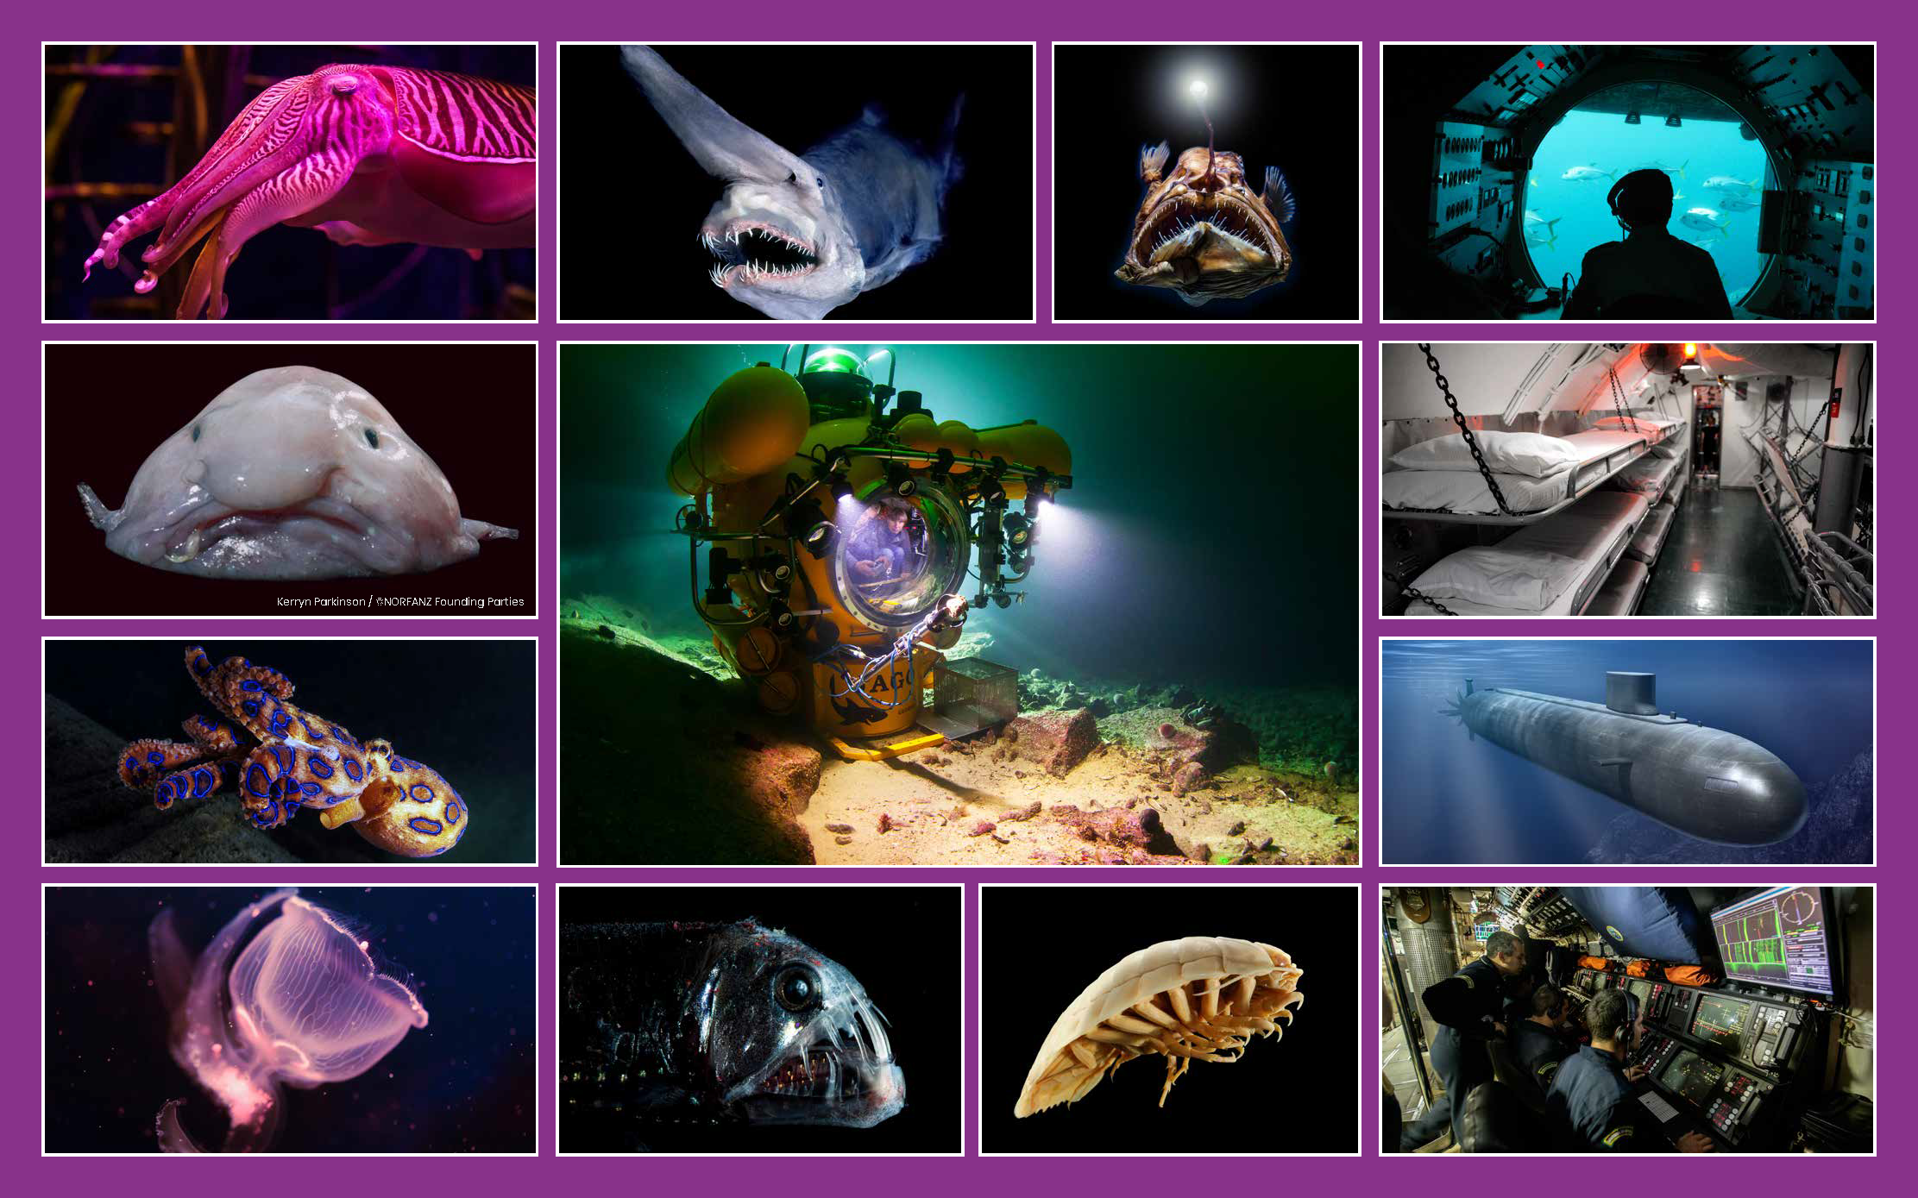
Class | 5th Class | Theme | Science and nature
Unit | 13 | Subtheme | Under the sea
Unit Genre | Explanation | OL Text Type | Oral report
Vocabulary | Tier 1 examples: creature, submarine, cramped, survive, dangerous, enemy  Tier 2 examples: environment, disproportionally, ancestors, crustacean, dim, murky, species, paralyses, toxic, technique, navigating  Tier 3 examples: gelatinous, isopod, bioluminescent, photoproteins, luminous, submersible
Lesson resources | Ocean plastic images, multimedia links

Fortnightly plan
Lesson 1 | Digital poster (Story mode)  Digital poster (Explore mode): Talk and discussion  Word walk  Group talking task: If I Were… | Lesson 3 | Digital poster (Explore mode): Talk and discussion  Digital poster (Let’s Talk mode): Ocean plastic flashcards  Group talking task: Perturbed by Plastic
Lesson 2 | Digital poster (Story mode): Recap  Digital poster (Question mode)  Pair talking task (Giving and Receiving Instructions): Describe and Draw | Lesson 4 | Group talking task (Oral report): The Plastic Puzzle

Lesson 1
Digital poster (Story mode)
Play either the Story mode 1 (starters) or Story mode 2 (flyers) for the class, depending on the ability level.

As they listen, ask the students to identify
- one fact they already knew
- one fact they found surprising and why
- one fact they would like to tell someone and why

Digital poster (Explore mode): Talk and discussion
Go to the Explore mode of the poster. Ask students the following questions:
- Where do these creatures live? What words are used to indicate this? (under the sea, deep, beneath, descend)
- Without pointing, name each of the creatures and locate where the picture of each creature is on the poster (Name: purple ocean squid, goblin shark, angler fish, blob fish, blue ringed octopus, bioluminescent, viper fish, giant deep-sea isopod - crustacean. Location on the poster: The viper fish is the fish in the second picture from the left on the bottom row/between the bioluminescent fish and the isopod/underneath the picture of the submersible)
- Taking each creature in turn, explore where its name might have come from (focus on: purple, goblin, angler, blob, blue ringed, luminescent, viper, isopod (iso=equal, pod=feet – creature with seven pairs of equal sized feet))
- What is the deep undersea zone sometimes called? (Midnight zone). Why do you think it is called this? (Sunlight does not reach this zone)
- Can you think of other words to describe the dark? (e.g. black, dim, pitch-dark, pitch-black, gloomy, inky, murky…). What word mean the opposite of ‘dark’? (light, bright, sparkling, sunny, brilliant, illuminated, luminous)
- How do undersea creatures perceive light? (through their eyes). What kinds of eyes have these creatures? (e.g. disproportionately large, tiny, black pupils – draw attention here to the other meaning of the word ‘pupil’)

Word Walk
Take a word walk through the word ‘light’. Look at synonyms, e.g. shine, glow, blaze, radiate, gleam, sparkle, luminate …; derivative forms such as e.g. luminous, illuminate. For extra challenge, explore the multiple-meanings of the word ‘light’. Scaffold students (as appropriate) when explaining what each of the following phrases means:
  - Please turn on the light
  - She is really light on her feet
  - The box is very light
  - Let’s light the fire
  - The shirt is light blue
  - The mood was extremely light
  - She has a light touch

Group Talking Task: If I Were…
Divide students into groups of three or four. Each student in turn indicates which creature he/she would like/not like to be and why: If I were a creature of the deep, I would/would not be a… because I would…

E.g. If I were a creature of the deep, I would be a blob fish because I would have no muscle mass and so I could be idle and sit around doing nothing all day! /If I were a creature of the deep, I would not be a Blue Ringed Octopus because I would be so toxic, I would have no friends left!

Lesson 2
Digital poster (Story mode): Recap
Play either the Story mode 1 (starters) or Story mode 2 (flyers) for the students again. Make sure they understand all of the vocabulary associated with the creatures:

Purple Ocean Squid: disproportionately large eyes, black pupils, navigate
Goblin Shark: extends, ancestors, existed, elongated snout, prey, shark
Angler Fish: tiny eyes, long spiky teeth, thin rod, attracts, protruding, consume
Blob Fish: slimy, gelatinous, low muscle mass, conserve, invertebrate
Blue Ringed Octopus: dangerous deadly, toxic, saliva, unique, paralyses
Bioluminescent: predators, photoproteins, illumination, ward off predators, lure in prey
Viper Fish: peek, hinged jaw

Digital poster (Question mode)
Go to the Question mode of the poster. Listen to each question and discuss the answers with the children briefly.

Q1. | Why does the submersible have powerful lights on it?
Q2. | What does the anglerfish use to lure its prey?
Q3. | How do you think the blobfish got its name?
Q4. | Why does the viperfish have such large eyes?
Q5. | Why do some sea creatures produce and emit light? Do you know what the term is for this?
Q6. | Which creature do you think is the strangest? Why?
Q7. | Submersibles don't stay underwater for very long? Why do you think this is the case?
Q8. | Why you do think submarines have no windows?
Q9. | Do you think exploring the deepest parts of the ocean is dangerous? Why?
Q10. | Do you think there are lots of other creatures in the ocean that we have yet to discover? Why or why not.

Pair Talking Task (Giving and Receiving Instructions): Describe and Draw
Divide students into pairs. Student A describes one of the creatures without naming it, giving instructions to Student B who then draws the creature, following instructions.
Encourage students to use some of the vocabulary explored. E.g.
- Draw a creature that is (shape, size, colour, name the species…)
- Give the creature (eyes, snout, teeth, other particular features; give specific instructions about the location of these features on the creature)
- Show the creature (e.g. extending, navigating, attracting, warding off, luring, attacking…)
Tell students to compare drawings for accuracy. Ask them to reflect on how the communication (listening and speaking) might be improved for greater accuracy (e.g. more specific description, more information about the location of the features, greater attention to instructions given …).
Students then reverse roles.

Lesson 3
Digital poster (Explore mode): Talk and discussion
Go to the Explore mode with students again.
Focus on the image of the submersible in the centre of the poster. Replay the story mode from where the submersible is introduced. Ask the students the following questions:
- Can you remember the name given to the vehicle which travels deep beneath the surface of the ocean? (submersible)
- Why are these vehicles small?(so they can move around easily)
- How do they see in the dark? (torches, cameras)
- What is the name given to larger underwater vehicles? (submarines)
- How are they different from the smaller submersibles? Why?
- What adaptations do animals make to compensate for the lack of light? (large eyes, bioluminescence)
- How was bioluminescence defined in the video clip (gives off its own light – i.e. it emits its own light)
- Do you notice anything interesting about the words for vehicles that dive deep beneath the ocean’s surface? (‘sub’). This is a prefix which means under, below, beneath (subaqua diving; submarine – under water; submersible – something designed to operate while submerged or below the water)

Digital poster (Let’s Talk! mode): Ocean Plastic
Go to the Let’s Talk mode of the poster. Click through the images. Ask students:
- What is the most shocking statistic you learned from flashcard 2?
- What are the implications of this statistic do you think?

Group Talking Task: Perturbed by Plastic
Divide students into groups. Each group is given a copy of one of the images in the Let’s Talk mode (Resource 1). Tell students to:
- Talk about how this image makes them feel and generate words to express these feelings (e.g. shocked, stunned, unsettled, overwhelmed, angry, outraged, furious, enraged, horrified, aghast…)
- Express their feelings in the form of an opinion, with a justification (e.g. In my opinion, I feel aghast at what I see in this image because it shows no concern for the ocean life)
- Write the most powerful words around the image (one child is the scribe and does all the writing on the picture)

Groups rotate around the room until they have recorded their feelings on each image. Then lead a whole class discussion focussed on the damage being done to the ocean by plastic.

Lesson 4
Group Talking Task (Oral Report): The Plastic Puzzle

Have students watch a video on the damage ocean plastic is causing (e.g. https://www.youtube.com/watch?v=KsuBUWPnJSQ)

Divide students into groups and have them brainstorm what each one of us can do to help reduce the impact of plastic on the ocean. Tell them to generate a list of 5 things we can do (e.g. Reduce: use fabric shopping bags instead of plastic; Reuse: water bottles and lunch boxes instead of disposable plastic bottes and plastic bags; Recycle: choose materials that lend themselves to being recycled instead of those that do not, e.g. polystyrene containers; Encourage: others to do the same)

Tell students to develop a slogan to encourage people to be more careful about using and disposing of plastic (e.g. Don’t ruin our oceans with plastic, think before you drink, keep your rubbish away from our fish, sweep the deep, be drastic with plastic…).
Students then present their solution to the class. Remind students that their report should have:

- Have a clear title
- A general opening statement outlining what the presentation is going to be about
- A series of coherent, logical points
- Use the present tense and formal language
- Linking points with time/causal connectives (e.g. first, next, meanwhile, finally, after a while, after some time, eventually …; because, as a result, although, unless, consequently, however, therefore …)
- A concluding statement

Lesson Resource 1: Ocean Plastic Images

