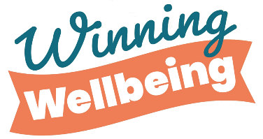
Coping Skills Checklist
Coping skills are things you can do to make yourself feel better when you are going through difficult times. When you are upset, the activities below are things you could try to help you feel better.
1. Tick off the skills you do now.
2. Cross out the ones that you feel would not work for you.
3. Circle the ones you would be willing to try.
▢ Practise deep breathing  ▢ Take a mindful walk  ▢ Visualise your favourite place  ▢ Picture your favourite things  ▢ Picture the people you care about  ▢ Slowly say the alphabet in your head  ▢ Focus on the words of a song you like  ▢ Move  ▢ Practise positive self-talk  ▢ Take a bath or a shower  ▢ Drink water  ▢ Count slowly to 100  ▢ Complete a crossword puzzle  ▢ Do a sudoku puzzle  ▢ Cook or bake something  ▢ Volunteer in the community  ▢ Do a random act of kindness  ▢ Read  ▢ Play with your pet  ▢ Meet up with a friend  ▢ Watch a funny movie | ▢ Read a funny book  ▢ Shuffle cards  ▢ Make something  ▢ Use a stress ball or a fidget toy  ▢ Walk  ▢ Exercise  ▢ Dance  ▢ Write in a journal  ▢ Draw  ▢ Talk to someone you trust  ▢ Create a calming playlist  ▢ Make a worry box  ▢ Sit in nature  ▢ Make a list of things you like  ▢ Write a gratitude list  ▢ Make a list of positive affirmations  ▢ Try a mindfulness colouring sheet  ▢ Try progressive muscle relaxation  ▢ Practise box breathing  ▢ Swing on a swing  ▢ Write down what is worrying you and throw it away

