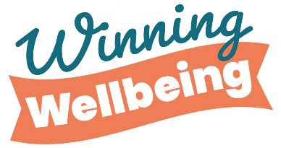

# DECISION-MAKING

## PROS AND CONS LIST

|  |  |
| --- | --- |
|  |  |

**How can I turn it around if I fail:**

**How I will feel if I succeed:**